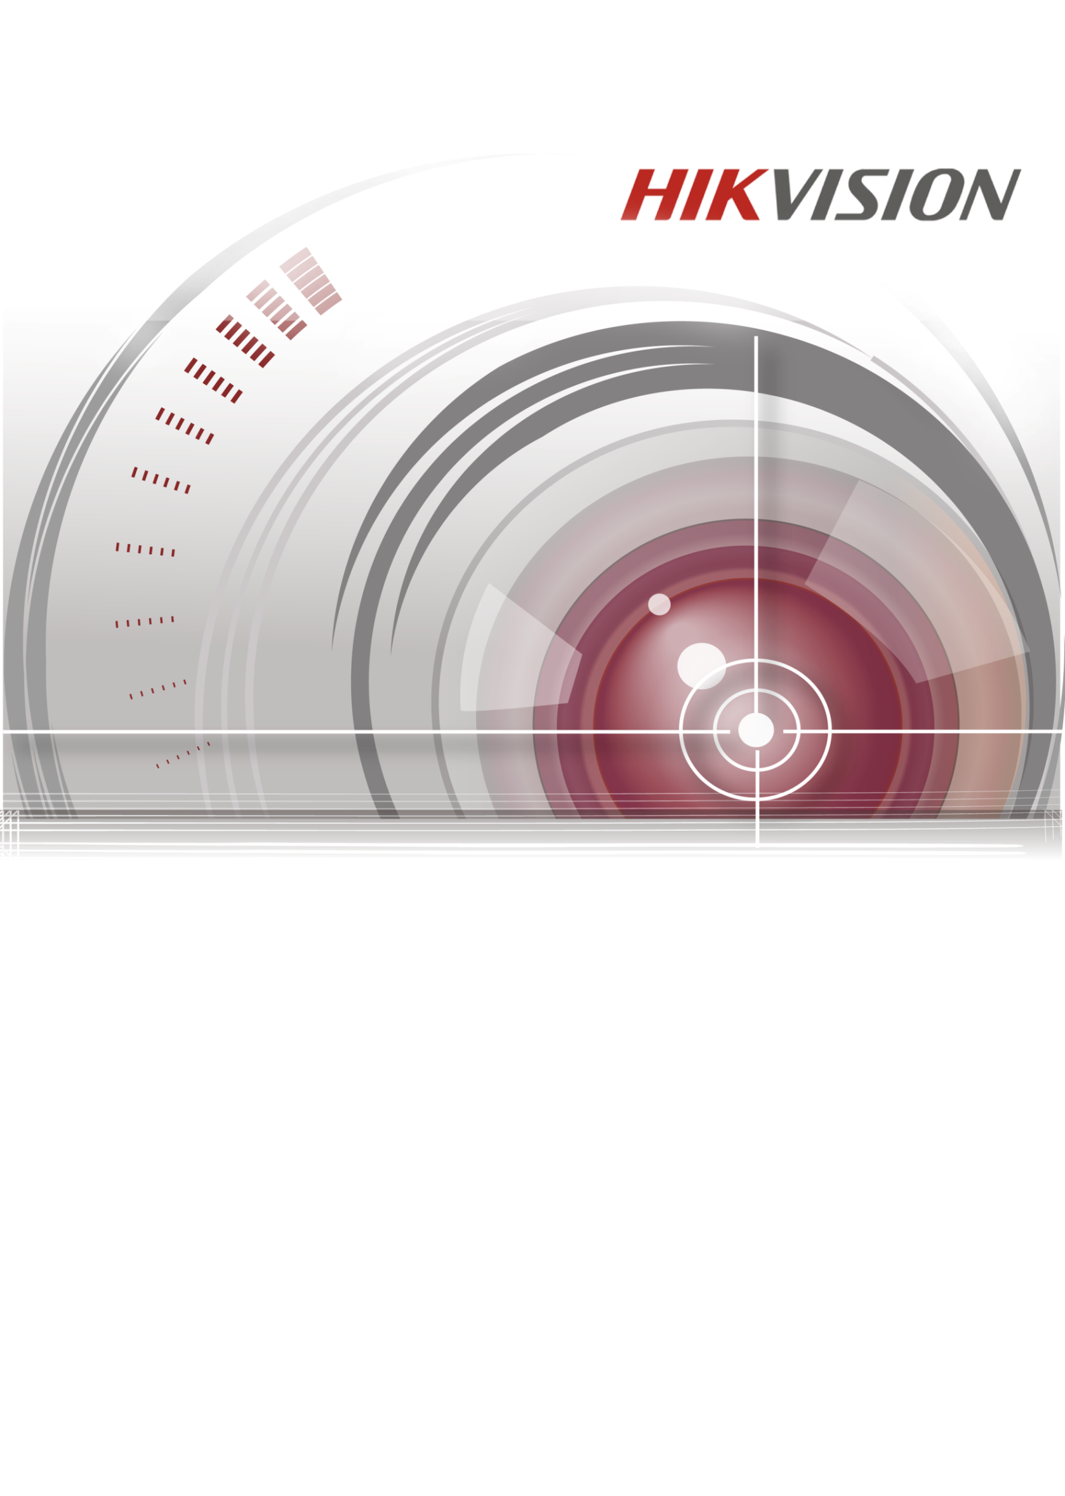

Hik-Connect Mobile Client Software (Android)

User Manual
V1.3.0
UD03013B

COPYRIGHT ©2016 Hangzhou Hikvision Digital Technology Co., Ltd.
ALL RIGHTS RESERVED.
Any and all information, including, among others, wordings, pictures, graphs are the properties of Hangzhou Hikvision Digital Technology Co., Ltd. or its subsidiaries (hereinafter referred to be “Hikvision”). This user manual (hereinafter referred to be “the Manual”) cannot be reproduced, changed, translated, or distributed, partially or wholly, by any means, without the prior written permission of Hikvision. Unless otherwise stipulated, Hikvision does not make any warranties, guarantees or representations, express or implied, regarding to the Manual.
About this Manual
This Manual is applicable to Hik-Connect Mobile Client Software.
The Manual includes instructions for using and managing the product. Pictures, charts, images and all other information hereinafter are for description and explanation only. The information contained in the Manual is subject to change, without notice, due to firmware updates or other reasons. Please find the latest version in the company website (http://overseas.hikvision.com/en/).
Please use this user manual under the guidance of professionals.
Trademarks Acknowledgement
and other Hikvision’s trademarks and logos are the properties of Hikvision in various jurisdictions. Other trademarks and logos mentioned below are the properties of their respective owners.
Legal Disclaimer
TO THE MAXIMUM EXTENT PERMITTED BY APPLICABLE LAW, THE PRODUCT DESCRIBED, WITH ITS HARDWARE, SOFTWARE AND FIRMWARE, IS PROVIDED “AS IS”, WITH ALL FAULTS AND ERRORS, AND HIKVISION MAKES NO WARRANTIES, EXPRESS OR IMPLIED, INCLUDING WITHOUT LIMITATION, MERCHANTABILITY, SATISFACTORY QUALITY, FITNESS FOR A PARTICULAR PURPOSE, AND NON-INFRINGEMENT OF THIRD PARTY. IN NO EVENT WILL HIKVISION, ITS DIRECTORS, OFFICERS, EMPLOYEES, OR AGENTS BE LIABLE TO YOU FOR ANY SPECIAL, CONSEQUENTIAL, INCIDENTAL, OR INDIRECT DAMAGES, INCLUDING, AMONG OTHERS, DAMAGES FOR LOSS OF BUSINESS PROFITS, BUSINESS INTERRUPTION, OR LOSS OF DATA OR DOCUMENTATION, IN CONNECTION WITH THE USE OF THIS PRODUCT, EVEN IF HIKVISION HAS BEEN ADVISED OF THE POSSIBILITY OF SUCH DAMAGES.
REGARDING TO THE PRODUCT WITH INTERNET ACCESS, THE USE OF PRODUCT SHALL BE WHOLLY AT YOUR OWN RISKS. HIKVISION SHALL NOT TAKE ANY RESPONSIBILITIES FOR ABNORMAL OPERATION, PRIVACY LEAKAGE OR OTHER DAMAGES RESULTING FROM CYBER ATTACK, HACKER ATTACK, VIRUS INSPECTION, OR OTHER INTERNET SECURITY RISKS; HOWEVER, HIKVISION WILL PROVIDE TIMELY TECHNICAL SUPPORT IF REQUIRED.
SURVEILLANCE LAWS VARY BY JURISDICTION. PLEASE CHECK ALL RELEVANT LAWS IN YOUR JURISDICTION BEFORE USING THIS PRODUCT IN ORDER TO ENSURE THAT YOUR USE CONFORMS THE APPLICABLE LAW. HIKVISION SHALL NOT BE LIABLE IN THE EVENT THAT THIS PRODUCT IS USED WITH ILLEGITIMATE PURPOSES.
IN THE EVENT OF ANY CONFLICTS BETWEEN THIS MANUAL AND THE APPLICABLE LAW, THE LATER PREVAILS.

Contents
Contents 1
Chapter 1 Introduction 3
1.1 Overview 3
1.2 System Requirements 3
1.3 Conventions 3
Chapter 2 Software Installation and Uninstallation 4
Chapter 3 User Registration and Login 5
3.1 Registering the Software 5
3.2 Login 12
3.3 Logout 15
Chapter 4 Device Management 16
4.1 Adding a Device 16
4.2 Managing the Device 21
4.2.1 Checking the Device Version 21
4.2.2 Editing the Device Name 22
4.2.3 Enabling/Disabling the Image Encryption 23
4.2.4 Checking Storage Status 24
4.2.5 Changing Device Password 26
4.3 Managing Security Control Panel 26
4.3.1 Configuring Partition Status 27
4.3.2 Managing Zone 28
4.4 Deleting a Device 33
4.5 Enabling DHCP 34
4.6 Enabling Hik Cloud P2P 35
Chapter 5 Live View 36
5.1 Starting and Stopping Live View 37
5.2 Switching Window Division 39
5.3 Turning On/Off Audio 39
5.4 Performing Digital Zoom 39
5.5 Controlling Pan and Tilt 39
5.6 Turning On/Off Two-way Audio 40
5.7 Capturing and Recording 41
5.8 Checking the Live View Quality 41
5.9 Opening the Door (Video Intercom Device) 42
Chapter 6 Remote Playback 44
6.1 Starting and Stopping Playback 44
6.2 Turning On/Off the Audio 45
6.3 Capturing and Recording 45
Chapter 7 Alarm Notifications Configuration 46
7.1 Enabling/Disabling Alarm Notification 46
7.2 Reading the Alarm Message 50
7.3 Deleting the Alarm Message 51
7.4 Alarm Messages of Video Intercom Device 52
7.4.1 Checking the Calling Message 52
7.4.2 Receiving Alarm Messages 54
Chapter 8 More Configuration 56
8.1 Managing Pictures and Videos 56
8.1.1 Managing the Video 56
8.1.2 Managing the Picture 57
8.2 Managing the Account 58
8.2.1 Changing Profile 58
8.2.2 Editing Real Name 59
8.2.3 Changing Account Password 60
8.2.4 Checking Other Information 60
8.3 Function Settings 61
8.3.1 Enabling/Disabling Message Push Notification 61
8.3.2 Saving Device Parameters 61
8.3.3 Enabling/Disabling Auto-receive Alarm after Power-on 61
8.4 Sending Feedbacks 61
8.5 Checking About 62

Introduction

Overview
The Hik-Connect mobile client software (Android) V1.3.0 is designed for the phone based on the Android 4.0 or above, which can generally manage Hivision products. By adopting the Hik Cloud P2P function, it is easy for you to remotely control NVRs, DVRs, network cameras, indoor stations and security control panels.
The Hik-Connect mobile client software (Android) V1.3.0 also provides the cloud service for managing cloud account and the added devices.
With this APP installed in your phone (Android), you are able to log onto the Hikvision devices via Wi-Fi, 3G or 4G.
Notes:
- Wi-Fi, 3G or 4G access service must be supported by the phone (Android).
- Network traffic charges may be produced when using the mobile software. Please refer to the local Internet Service Provider.

System Requirements
Android 4.0 or above.

Conventions
In order to simplify the description, we define the “Hik-Connect mobile client software (Android)” as “software” and “DVR”, “NVR”, “encoder”, “network camera”, “network camera”, etc. as “device” in the following chapters.

Software Installation and Uninstallation
Steps:
- Log onto the Google Play.
- Input “Hik-Connect” to search the mobile client software.
- Download and install it on your phone.
- After installing the software, tap 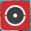 to run the software.
If you want to uninstall the software, tap and hold the icon on your phone until the icon turns to 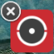. Tap to uninstall the software.

User Registration and Login

Registering the Software
When you use the software for the first time, you should register a Hik-Connect account.
Task 1: Registering by Mobile Phone Number
Steps:
- Tap the icon to run the software.
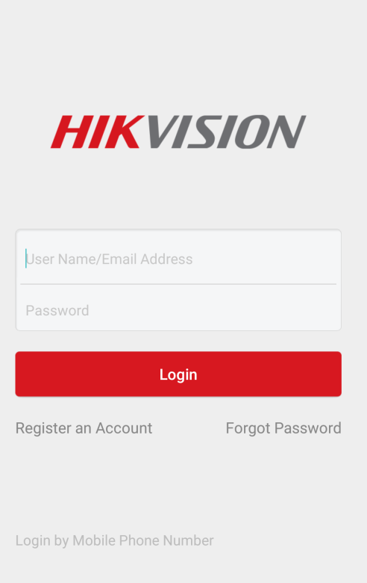
- Tap Register an Account in the login interface.
- Tap Terms of Service to read the agreement.
- Check Read and Agree to accept the agreement.
- Tap Register by Mobile Phone Number.
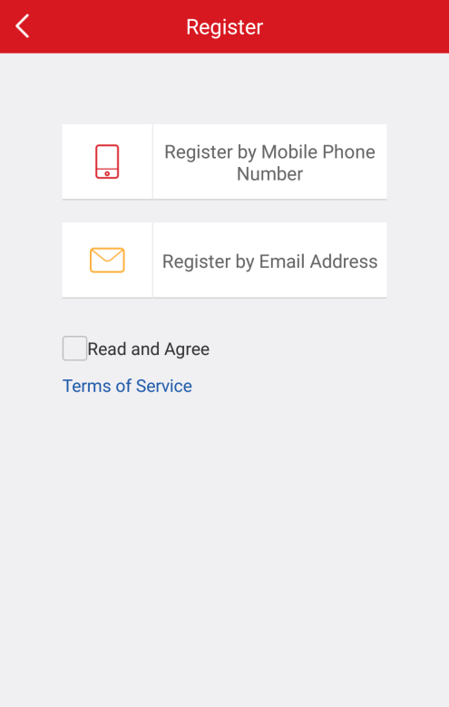
- Select a target region in the Region interface.
Notes:
- The region cannot be changed once you have selected.
- You should select an accurate region. Or it may affect the software operation.
- Tap Finish at the upper-right corner of the interface.
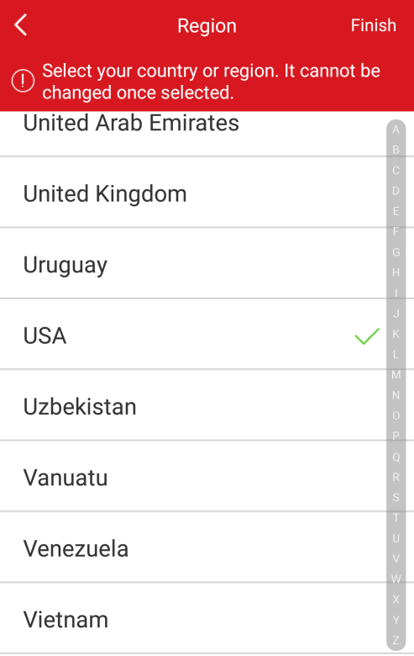
- Input your mobile phone number in the Mobile Phone Number interface and tap Get Verification Code. The verification code will be sent to your mobile phone.
Note: You can also tap Region to change the region.
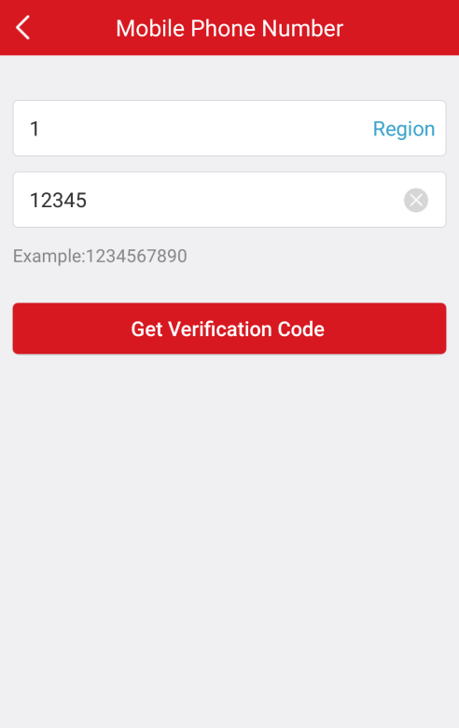
- Input the received verification code in the box and tap Next.
Note: The SMS may be delayed. If no messages received, tap Get Again after 60s to receive the verification code again.
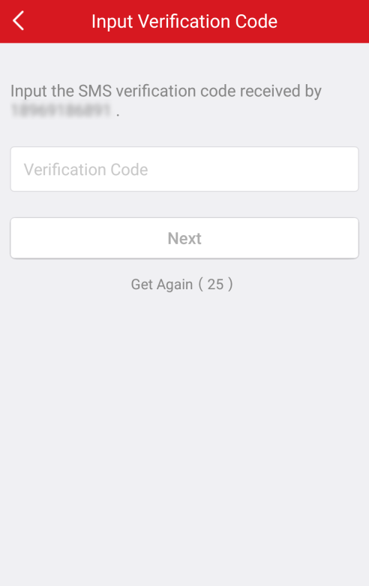
- Input a user name and a password. And confirm the password in the Account Settings interface. Tap Finish to complete registering.
Or tap Cancel at the upper-left corner of the interface and tap OK in the pop-up window to cancel the registering.
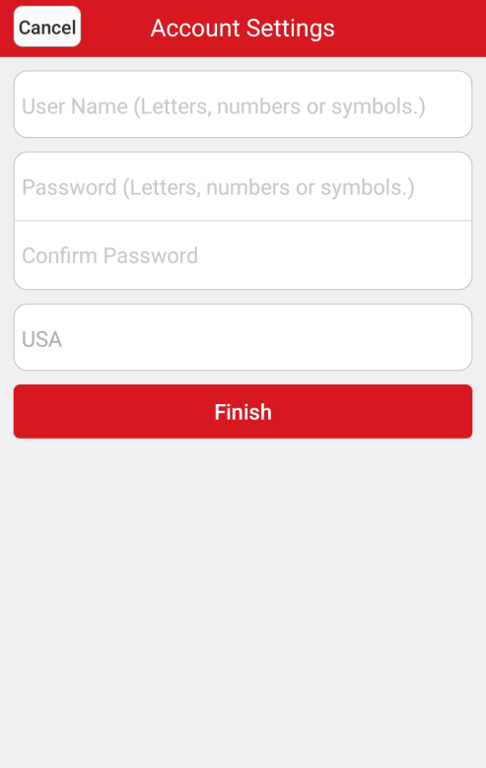
Or tap the Cancel at the upper-left corner of the interface and tap OK in the pup-up window to cancel the registering.
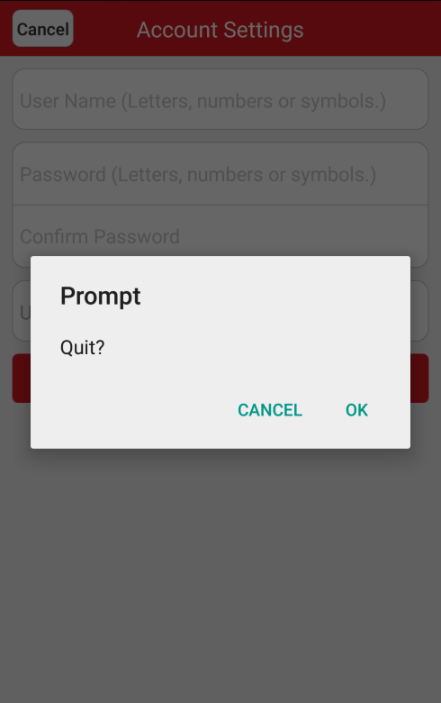
Note: You can change the password in the More interface after login. For details about changing password, see Changing Password in Section 8.2 Managing the Account.
- A user name cannot contain any of the following characters: / \ : * ? “ < > |. And the length of the password cannot be less than 6 characters.
- For your privacy, we strongly recommend setting the password to something of your own choosing (using a minimum of 8 characters, including upper case letters, lower case letters, numbers, and special characters) in order to increase the security of your product.
- Proper configuration of all passwords and other security settings is the responsibility of the installer and/or end-user.

Task 2: Registering by E-mail Address
Steps:
- Tap Register by E-mail Address.
- Select a target country or region and tap Finish at the upper-right corner of the interface.
Notes:
- The country or the region cannot be changed once you have selected.
- You should select an accurate country. Or it may affect the software operation.
- Input your email address and tap Next. The verification code will send to the target email address.
Or tap Previous to go back to the previous step.
Or tap Cancel to cancel registering.
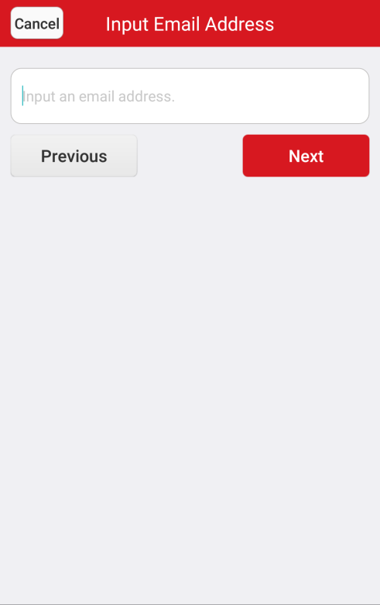
- Input the received verification code in the Verification Code box and tap Next.
Or tap Previous after 60s to return to the previous step.
Or tap Cancel at the upper-left corner of the interface to cancel the registering.
Note: The email may be delayed. If no emails received, tap Previous after 60s. Perform steps 3 and 4 again to receive and input the verification code.
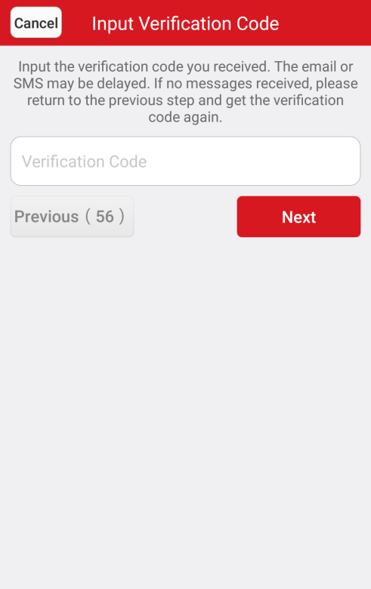
- Input a user name and a password. And confirm the password in the Account Settings interface.
- Tap Finish to complete registering.
Or tap Cancel at the upper-left corner of the interface and tap OK in the pop-up window to cancel registering.
You can change the password in the More interface after login. For details about changing password, see Changing Password in Section 8.2 Managing the Account.
- A user name cannot contain any of the following characters: / \ : * ? “ < > |. And the length of the password cannot be less than 6 characters.
- For your privacy, we strongly recommend setting the password to something of your own choosing (using a minimum of 8 characters, including upper case letters, lower case letters, numbers, and special characters) in order to increase the security of your product.
- Proper configuration of all passwords and other security settings is the responsibility of the installer and/or end-user.

Login
Steps:
- Tap the icon to run the software.
- Input the registered user name or email address. And input the password.
Or
- Tap Login by Mobile Phone Number at the bottom of the interface to change the login type.
- Enter the region code or tap Region to select the target region code.
- Input the mobile phone number and the password.
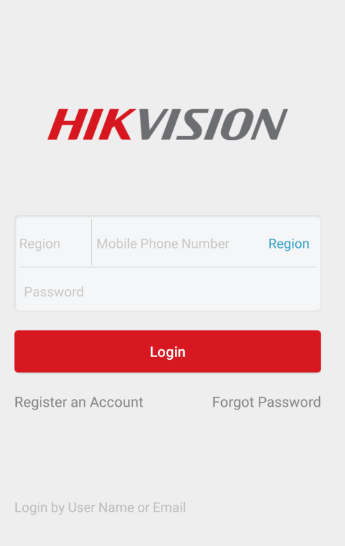
- Tap Login to enter the main interface.
If you forget the password, you can
- Tap Forgot Password.
- Tap Reset by User Name/Email Address or Reset by Mobile Phone Number.
Or if you want to cancel the operation, tap Cancel.
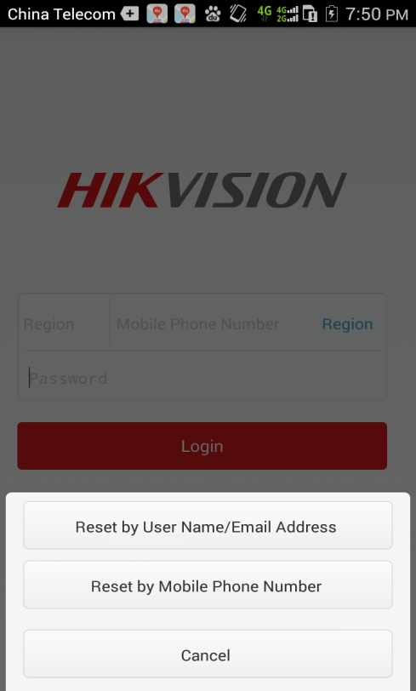
- Enter the user name or the email address if you choose Reset by User Name or Email Address in the Verify Account interface.
Or enter the mobile phone number if you choose Reset by Mobile Phone Number in the Verify Account interface.
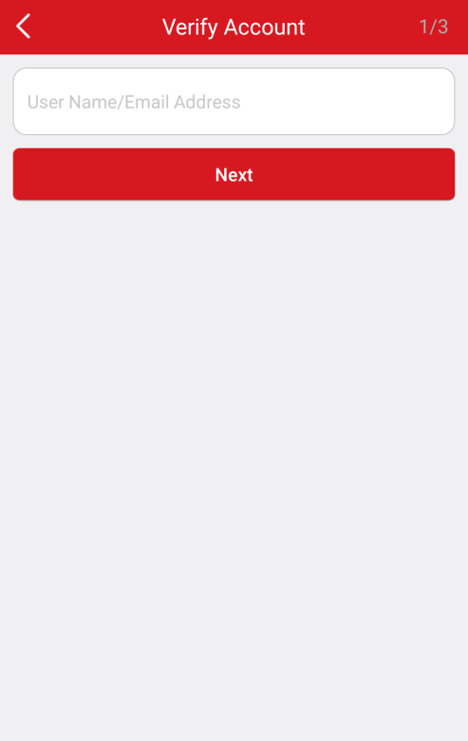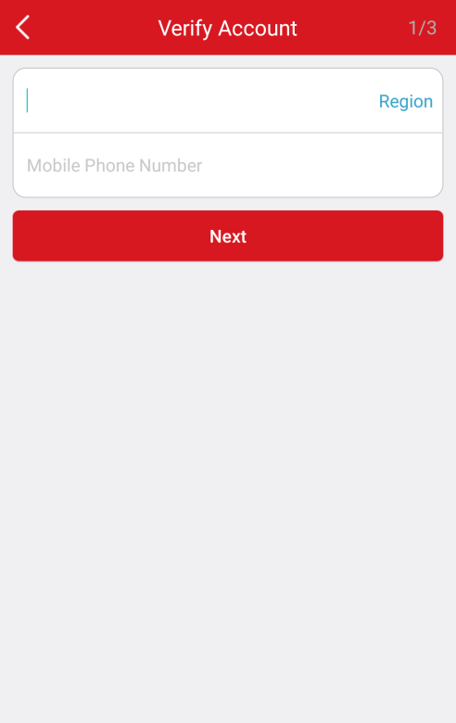
- Tap Next. A verification code will be sent to your registered phone or the email address.
- Input the verification code in the next interface and tap Next.
Or tap Previous after 60s to return to the previous step.
Or tap Cancel to cancel the operation.
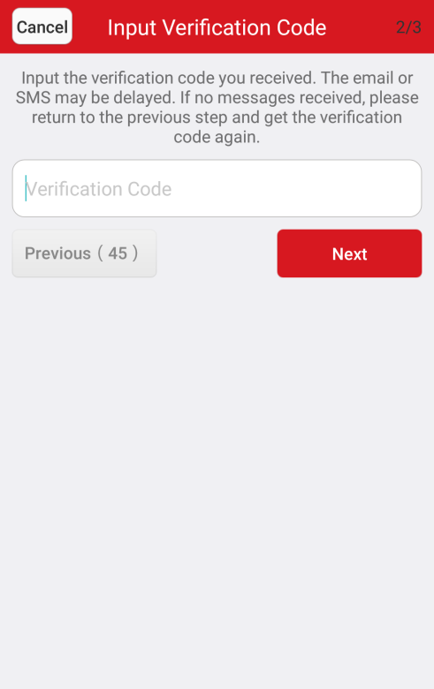
- Input a new password and confirm the new password in the Change Password interface.
- Tap Submit to complete password reset.
Or tap Cancel at the upper-left corner of the interface and tap OK to cancel the operation.
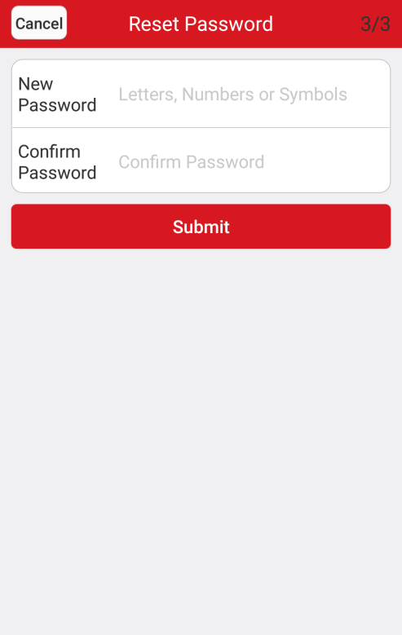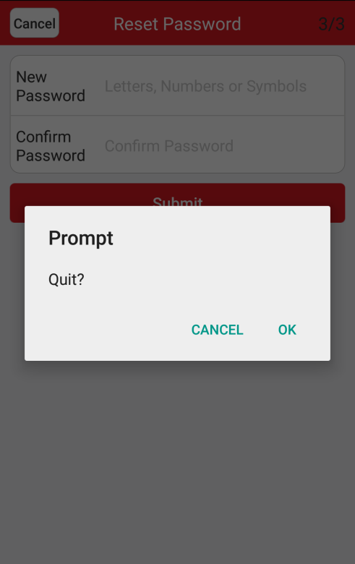
      - For your privacy, we strongly recommend setting the password to something of your own choosing (using a minimum of 8 characters, including upper case letters, lower case letters, numbers, and special characters) in order to increase the security of your product.
      - Proper configuration of all passwords and other security settings is the responsibility of the installer and/or end-user.

Logout
Before you start:
You should login to the software.
Steps:
- In the main interface, tap the icon 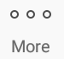.
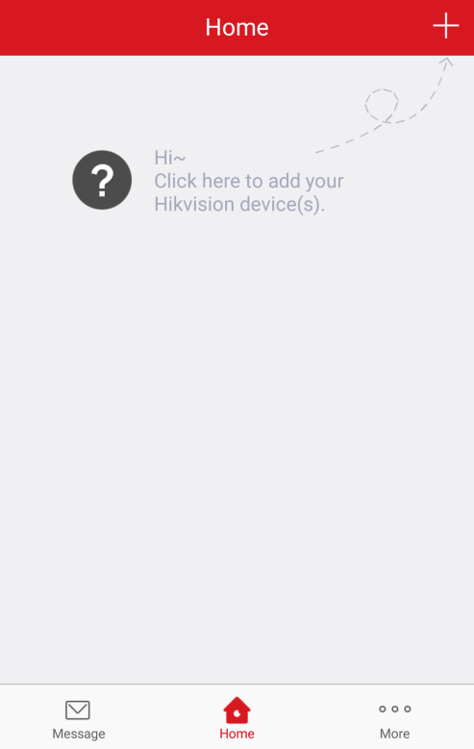
- Tap the button in the More interface.
- Tap OK in the pop-up message box to logout.
Or you can cap Exit to exit the software.
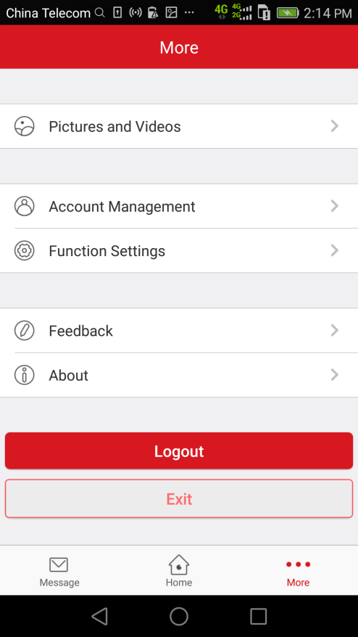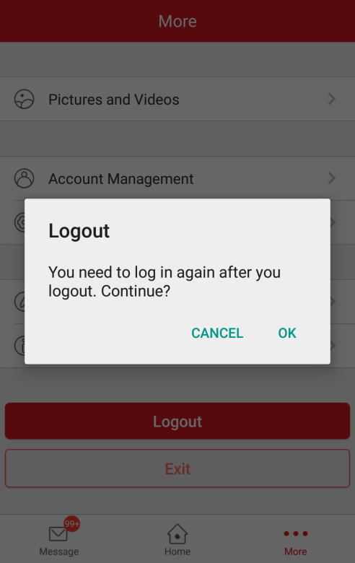

Device Management
Purpose:
You need to add a device before managing the live view, the playback, etc.
Before you start:
Make sure that the device DHCP and Hik Cloud P2P are enabled.
By default, the DHCP and the Hik Cloud P2P of the Hikvision devices are enabled. If the DHCP and Hik Cloud P2P are disabled, you need to enable them manually.
For detailed information about enabling Hik Cloud P2P, refer to Section 4.5 Enabling DHCP and Section 4.6 Enabling Hik Cloud P2P.

Adding a Device
Purpose:
Add Hikvision devices on the software to manage the live view, playback, and other functions.
Before you start:
For adding the indoor station of the video intercom and the security control panel, activate them before adding.
Make sure the device is powered on.
Steps:
- Tap the home icon 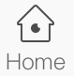 at the bottom of the interface.
- In the Home interface, tap the icon at the upper-right corner.
- Scan the device QR code.
Note: Normally, the QR code is on the back cover of the device.
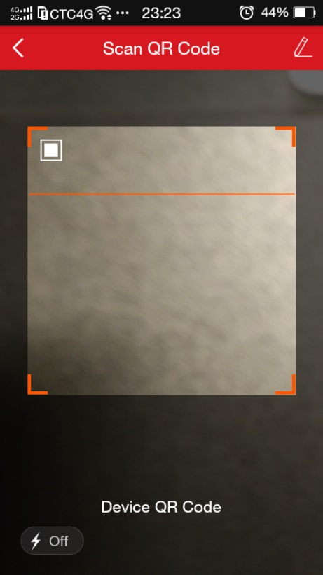
Or
- Tap the icon at the upper-right corner and input the device serial No. manually.
- Tap the icon 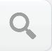 to search.
Note: The detectors cannot be added by manually inputting.
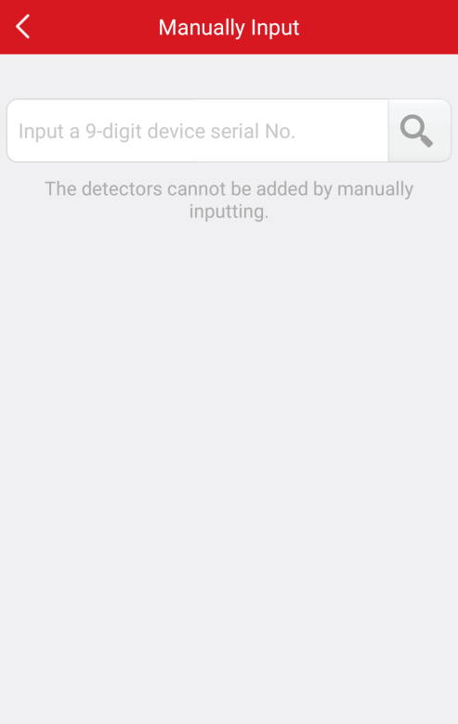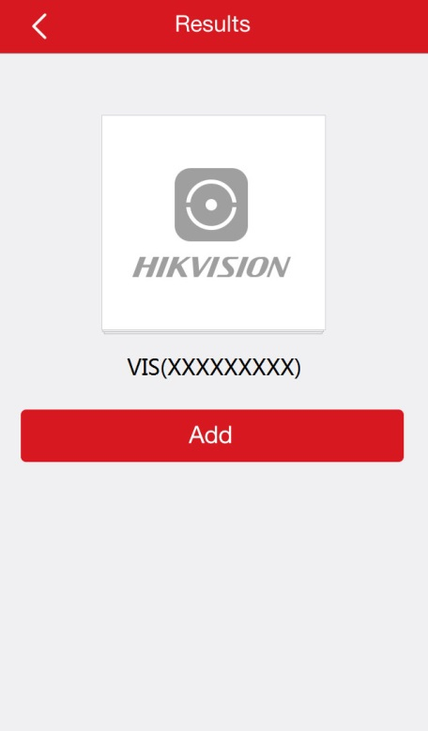
If the device is offline,
- Tap Connect to a Network. You can choose Wired Connection or Wireless Connection.
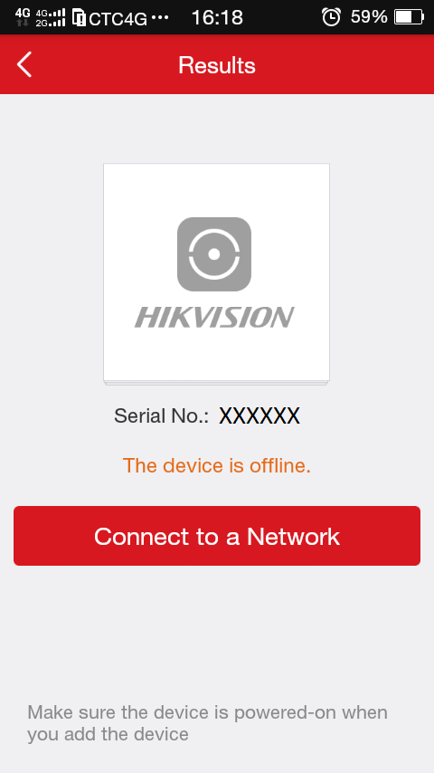
- If you choose Wired Connection, tap Connected to connect to the network.
Notes:
- You should connect the device to a router.
- Make sure the device is powered on.
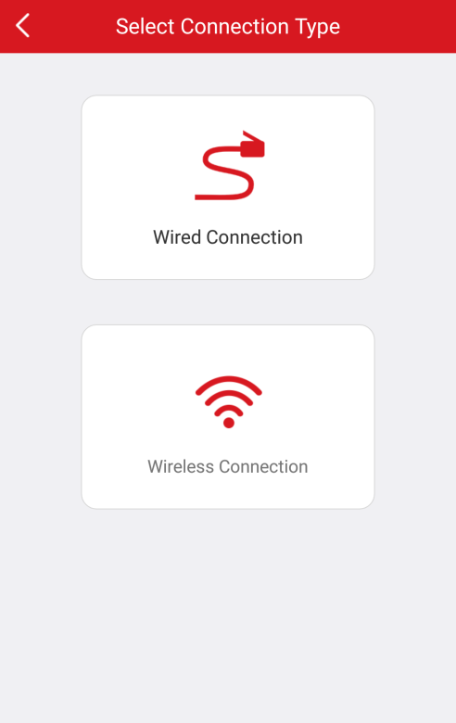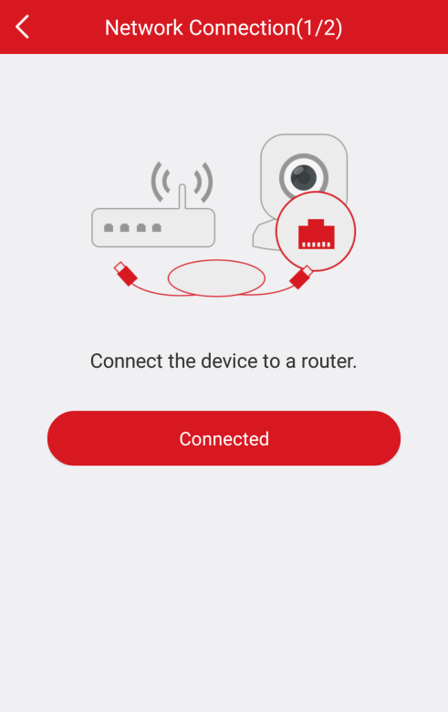
Or if you choose Wireless Connection, input the password in the Network Connection interface and tap Next to connect to the network.
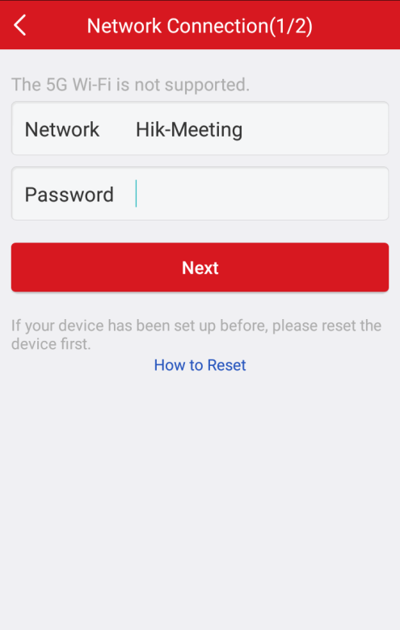
Notes:
- If you choose wireless connection, you should turn on the phone Wi-Fi function and select a Wi-Fi to connect. The selected Wi-Fi name will be displayed on the Network Connection interface.
- Reset the device before you configure the device Wi-Fi connection if it is not the first time to use the device.
- Make sure the device is powered on.
- (Optional) If the device is not activated, you need to customize a password and tap Activate to activate the device.
Note:
- The password is used for logging in the device via the web version, iVMS-4200, etc.
- The password should contain 8 to 16 characters with the combination of numbers, letters and symbols.
      - For your privacy, we strongly recommend setting the password to something of your own choosing (using a minimum of 8 characters, including upper case letters, lower case letters, numbers, and special characters) in order to increase the security of your product.
      - Proper configuration of all passwords and other security settings is the responsibility of the installer and/or end-user.
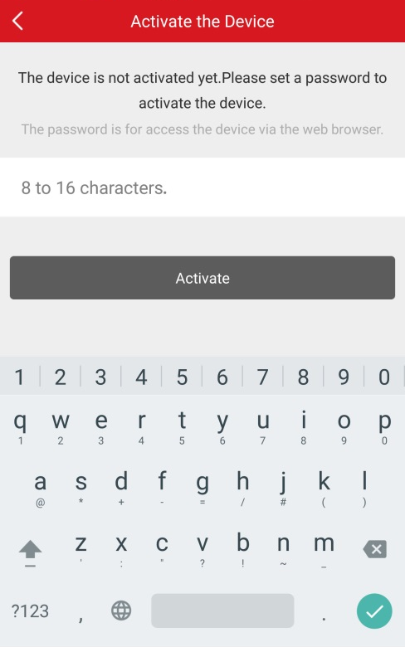
- In the Results interface, tap Add.
- Enter the device verification code and tap OK.
Notes:
- You can find the device verification code on the device label. If there is no device verification code, input the default code ABCDEF.
- If you scan the device QR code to add, the verification code entering interface will not be popped up. The QR code includes the verification code information.
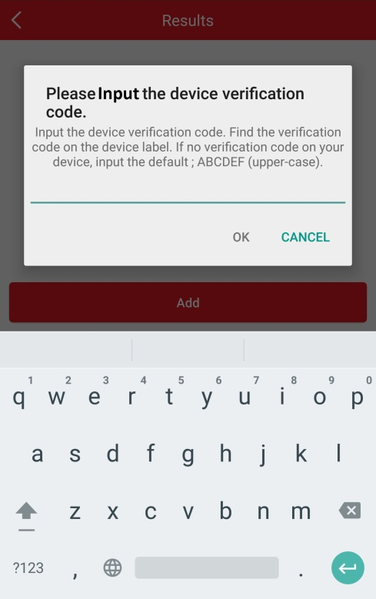
- Tap Finish to finish the operation.
Or tap Add Another Device to add more devices to the software.
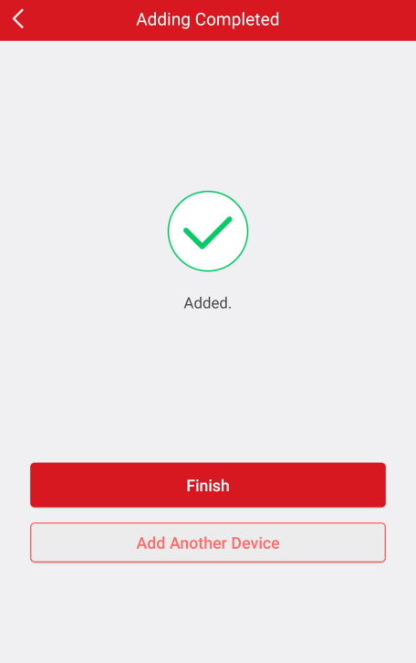
Notes:
- For video intercom devices, when scanning the QR code or inputting the serial No. of the indoor station, the corresponding door station will be displayed in the software automatically. You cannot modify the indoor station name and the door station name.
- An indoor station can be linked to multiple door stations.

Managing the Device

Checking the Device Version
Steps:
- Tap the device name in the Home interface to enter the device configuration interface if there is only one channel under the device.
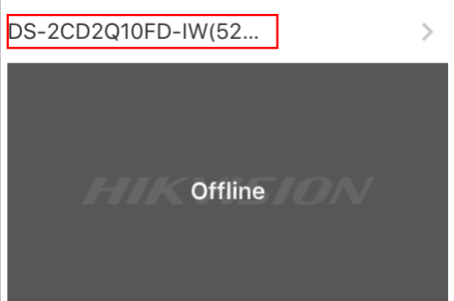
If there is more than one channel under the selected device, tap the device name and tap the icon at the upper-right corner to enter the Settings interface.
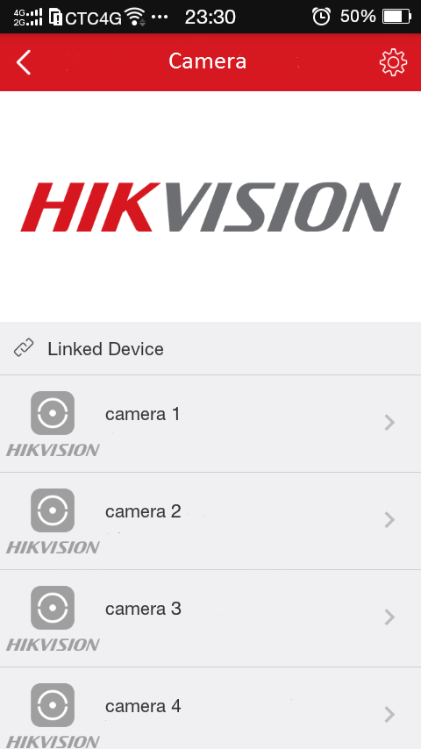
You can also
  - Tap the device screenshot to enter the live view interface.
  - Tap the icon at the upper-right corner to enter the device setting interface.
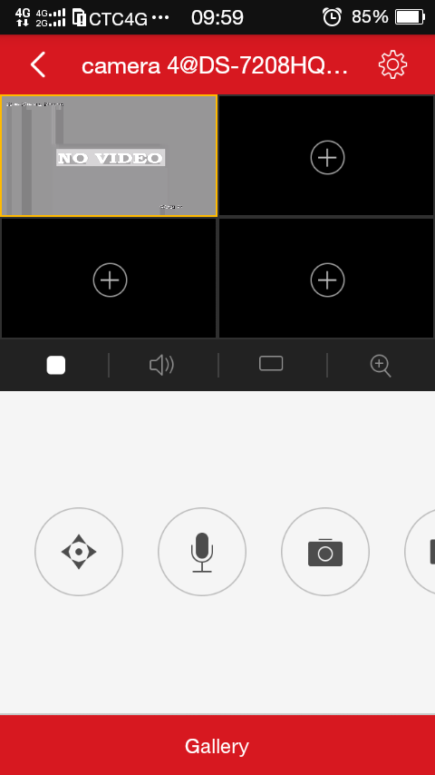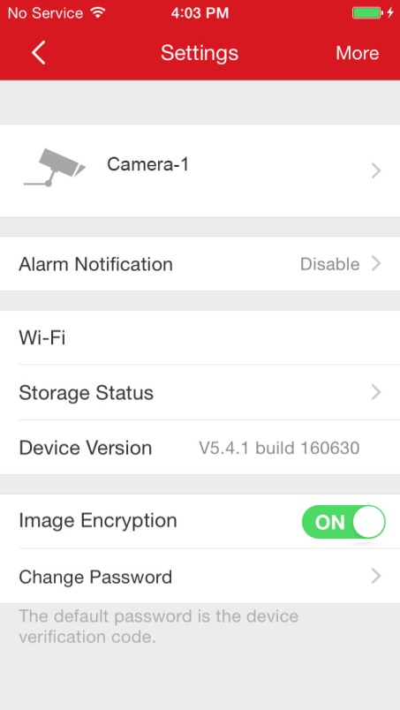
- You can check the device version in this interface.

Editing the Device Name
Steps:
- In the Settings interface, tap the device name to enter the Edit Device Name interface if there is only one channel under the device.
- Edit the device name.
- Tap at the upper-right corner to complete editing the device name.
Or if there are two or more channels under the target device, you can
- Tap the device name in the Home interface to enter the linked device list interface.
- Tap the icon and tap the device name to edit the device name.
- Tap to complete editing the device name.
Or you can also tap the target linked device in the linked device list and tap the linked device name to change the linked device name. Tap to complete editing.
Note: Up to 50 characters can be entered when editing the device name and the linked device name.

Enabling/Disabling the Image Encryption
If you enabling the Image Encryption, you should enter the password the first time you enter the live view interface or the playback interface.
If you change the phone to login the same account, you should enter the password again to perform the live view or the playback.
Steps:
- Tap ON on the right of the Image Encryption row and tap OK in the pop-up window to confirm disabling. The icon will turn to .
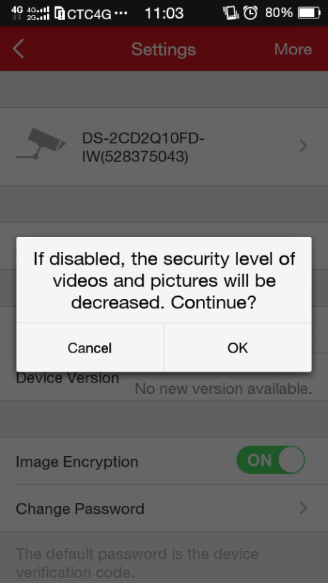
Or tap OFF on the right of the Image Encryption row. The icon will turn to the icon .
Enter the device verification code. The verification code is located on the device label. If no verification code found, input the default code: ABCDEF.
Note: The Settings interface will display functions depending on different device types.

Checking Storage Status
Purpose:
You are able to check the device storage status.
Steps:
- In the Settings interface, tap the device name to enter the Edit Device Name interface if there is only one channel under the device.
- Or if there are two or more channels under the target device, you can
- Tap the device name in the Home interface to enter the linked device list interface.
- Tap the icon to enter the Settings interface.
- Tap Storage Status to enter the Storage Status interface. You are able to check the memory card status.
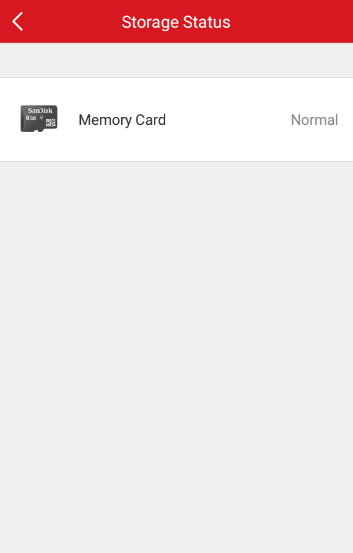
If the memory card is not initialized, tap the Memory Card to enter the Initialize Storage interface and tap Initialize to initialize the memory card.

Changing Device Password
Steps:
- In the Settings interface, tap Change Password.
- Tap Edit to enter the Change Password interface.
- Input the old password, the new password and confirm the new password in the box.
- Tap to confirm password changing.
- A user name cannot contain any of the following characters: / \ : * ? “ < > |. And the length of the password cannot be less than 6 characters.
- For your privacy, we strongly recommend setting the password to something of your own choosing (using a minimum of 8 characters, including upper case letters, lower case letters, numbers, and special characters) in order to increase the security of your product.

Managing Security Control Panel
Purpose:
You are able to manage the partition and the zone of the security control panel.
The following picture displays the Security Control Panel list in the Home interface.
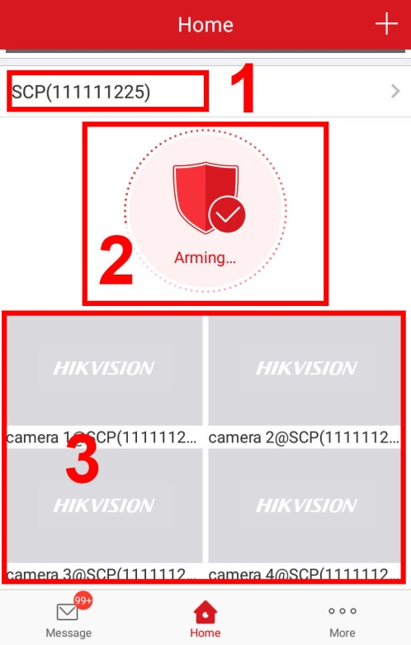
The following table describes each part of the security control panel in the list of the Home interface.
            - Description of Each Part of Security Control Panel
No. | Description
1 | Security Control Panel Name
2 | Device Status | Arming | 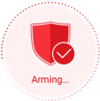
 |  | Disarming | 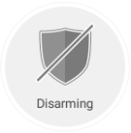
 |  | Offline | 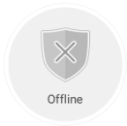
3 | Device Linked Cameras

Configuring Partition Status
Tap the security control panel device status in the device list of the Home interface to enter the Partition interface. If the device contains more than one partition, you are able to change between different partitions at the top of the interface.
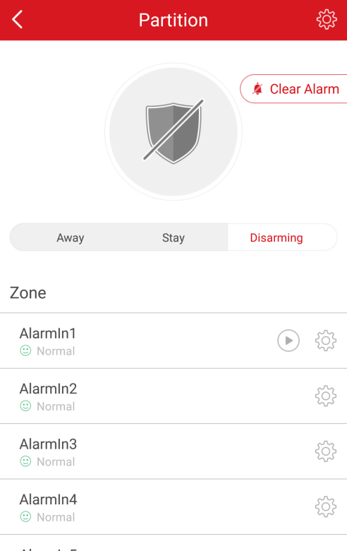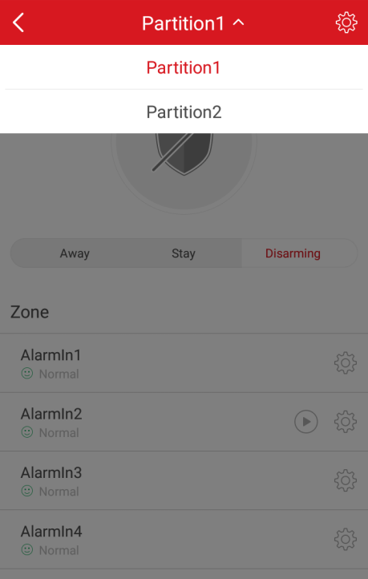
You can configure the partition status to Away, Stay and Disarming. It is also available to stop the alarm by tapping Clear Alarm.
Away: | 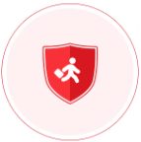 | Enable the status when you are not in the partition.
Stay: | 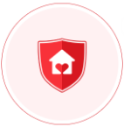 | Enable the status when you are in the partition.
Disarming: | 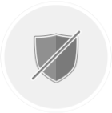 | Enable the status when you do not want to arm the partition.
You are also able to check the Zone status, including Normal, Fault, Bypass, Normal Battery Voltage, Low Battery Voltage and Alarm.

Managing Zone
Purpose:
You are able to configure the zone name, the zone type, the detector type, the entering delay time, the exiting delay time, the zone bypass and the linked camera.

Configuring Zone Name
Steps:
- Tap the icon to enter the Settings interface.
- Tap the zone name to enter the Edit Zone Name interface.
- Edit the zone name and tap the icon .
Note: 1 to 50 characters are allowed.
Tap the icon to go back to the Settings interface.

Configuring Zone Type
Steps:
- Tap the icon to enter the Settings interface.
- Tap the zone type to enter the Zone Type interface.
- Select a zone type to determine the zone property.
- Tap the icon to go back to the Settings interface.
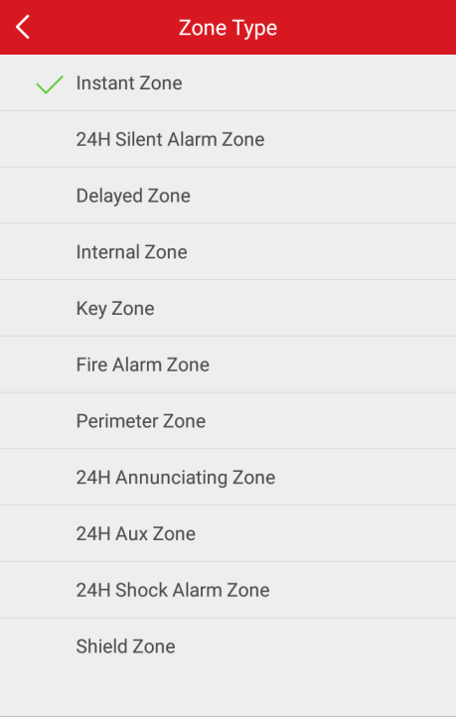
- (Optional) If you select Delayed Zone, you are able to configure the Entering Delay Time and the Exiting Delay Time in the Settings interface.
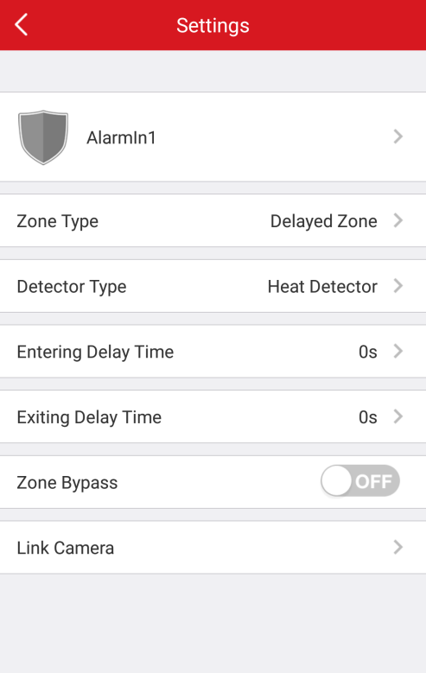

Configuring Detector Type
Steps:
- Tap the icon to enter the Settings interface.
- In the Settings interface, tap Detector Type to enter the Detector Type interface.
- Select a detector to determine the zone detector type.
- Tap the icon to go back to the zone Settings interface.
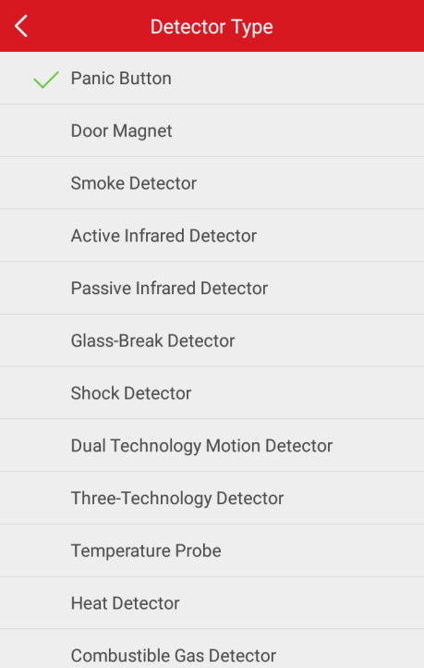

Configuring Zone Bypass
Purpose:
You are able to configure the zone to bypass if the zone detector is destroyed, offline, etc., to allow other zones working properly.
Steps:
- Tap the icon to enter the Settings interface.
- Tap the icon / to enable/disable the zone bypass function.

Linking Camera
Purpose:
You are able to link the camera to the zone for zone monitoring.
Steps:
- In the Settings interface, tap Link Camera to enter the Link Camera interface.
- Tap a camera in Available Camera group. You are able to slide the camera group from left to right or from right to left to view the whole available cameras.
- Tap Link to link the select camera to the zone.
- Tap Finish to finish linking.
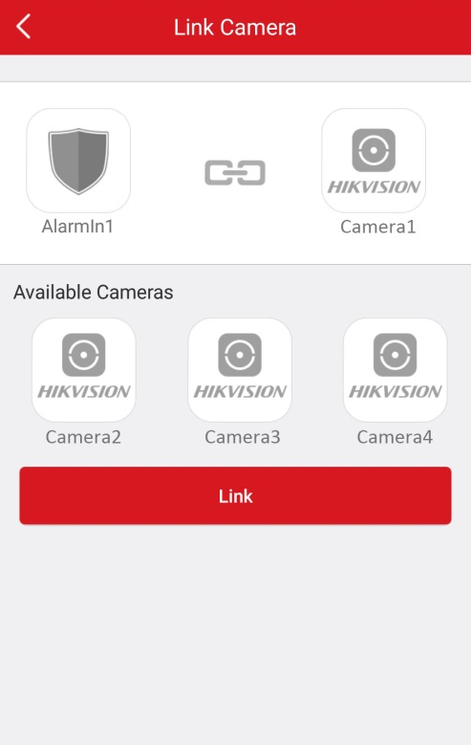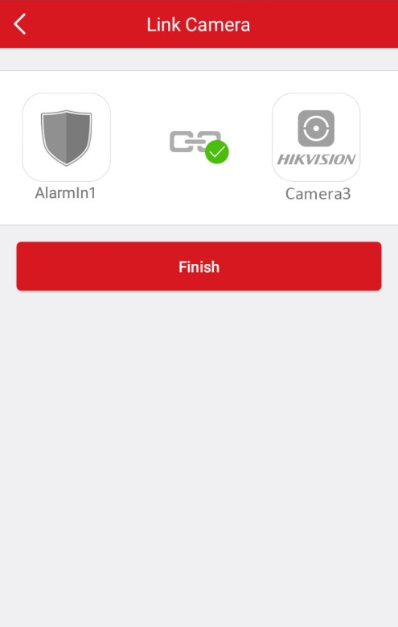
The icon will be displayed on the right of the target zone in the Zone list in the Partition interface after linking a camera. You are able to tap the icon to start live view of the linked camera.
For details about checking the live view of the linked camera, see Chapter 5 Live View.
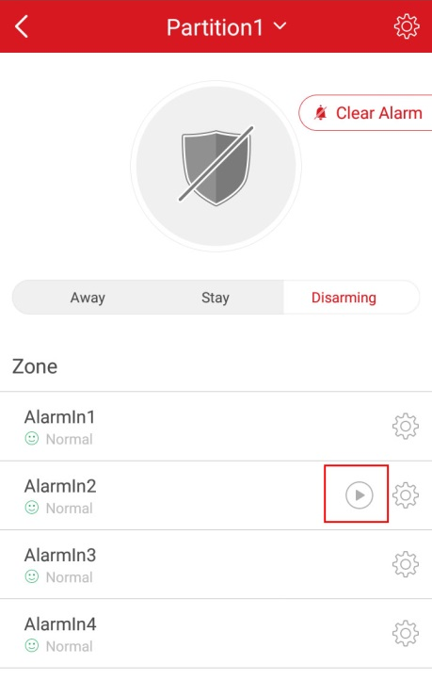
Or if you want to cancel the linkage, enter the Link Camera interface and tap Cancel Linkage to cancel the camera linkage.
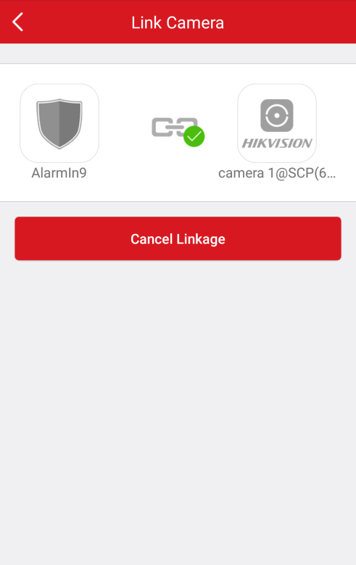

Deleting a Device
Steps:
- In the Settings interface, tap More at the upper-right corner of the interface.
- Tap Delete Device in the pop-up window.
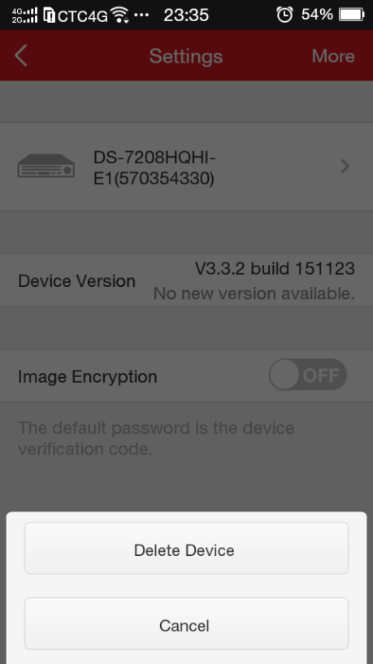
Note: When deleting the indoor station, the corresponding door station will be deleted.

Enabling DHCP
Purpose:
By default, DHCP of Hikvision devices that can be added to the software are enabled. You can also manually enable/disable DHCP.
Steps:
- Open the web browser on your PC.
- Input the device IP address and press the Enter key on your keyboard.
- Input the device user name and the password to login. Here we use the network camera as an example.
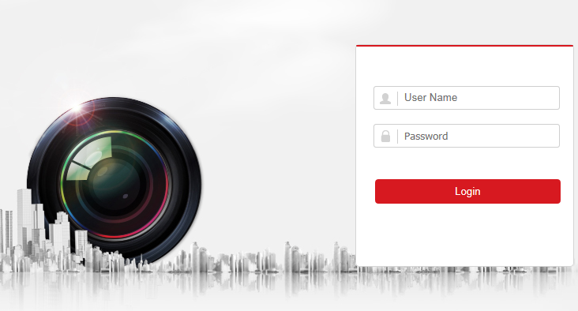
- Click Configuration -> Network -> Basic Settings to enter the Basic Settings interface.
- Enable DHCP.
Note: After enabling DHCP, DNS address will be allocated automatically.
- Click Save to save the configuration.
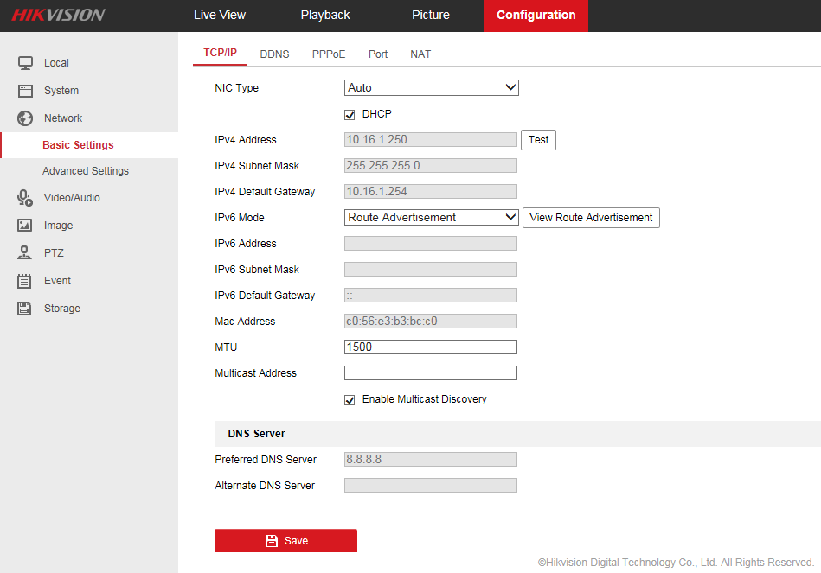
Note: For the device of security control panel, you are able to configure DHCP in iVMS-4200 Client Software. For details, see the user manual of iVMS-4200 Client Software.

Enabling Hik Cloud P2P
You should enable the Hik Cloud P2P function before adding the device to the software.
By default, the Hik Cloud P2P function in Hikvision devices that can be added to the software are enabled.
Here we use the network camera as an example. You can check the camera Hik Cloud P2P in the Platform Access interface in the browser.
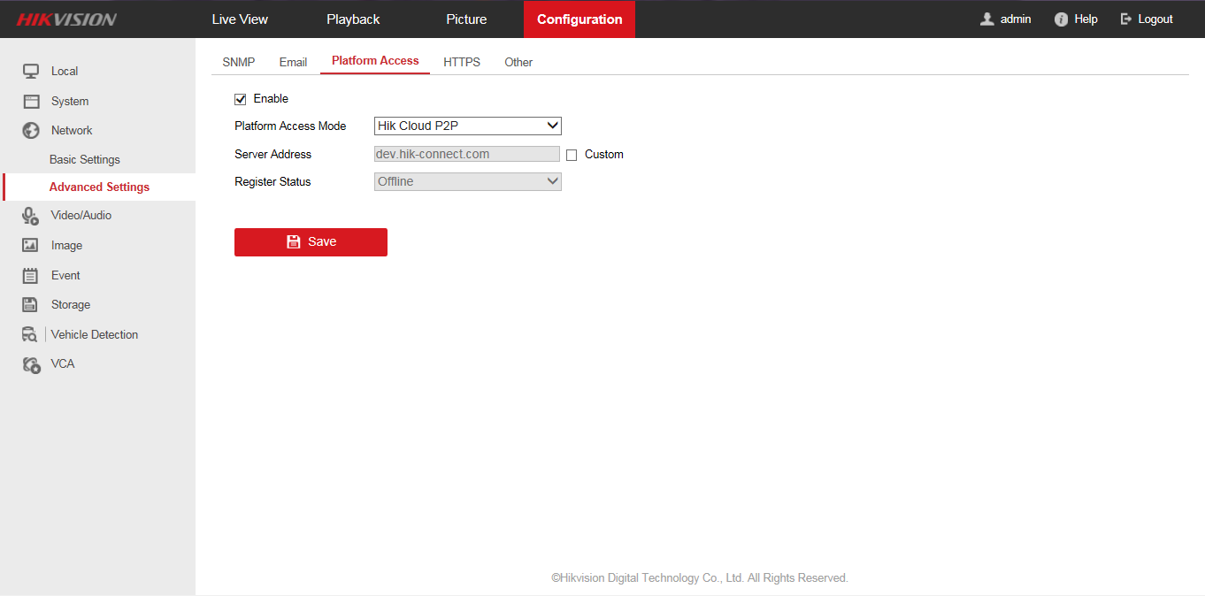
Note: Hik-Cloud P2P of the security control panel cannot be manually configured.

Live View
Purpose:
When the device is successfully added, you can manage the live view, control PTZ movement, manage two-way audio, capture, record and operate other functions.

Tap the home icon 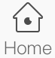 and tap the target device screenshot on the home interface to enter the Live View interface. The screen will be displayed in 4-division mode by default.
The table displayed below is the icons description in the Live View interface:
Icon | Description
 | Start live view.
 | Stop live view.
 | Turn Audio on/Mute
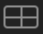 | 4-window division.
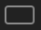 | Single-window division.
 | Digital Zoom
 | Start/stop controlling pan and tilt.
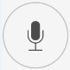 | Start/stop two-way audio.
 | Capture.
 | Record.
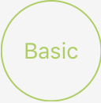 | Basic and high definition video quality.
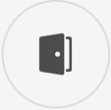 | Open the door.  Note: For the video intercom device only.
Note: You can slide on the screen to show the hidden icons.

Starting and Stopping Live View
Steps:
- Tap the device screenshot to enter the live view interface. By default, the live view interface is displayed in 4-window division.
Or you are able to rotate your mobile phone to view the live view window in full screen mode.
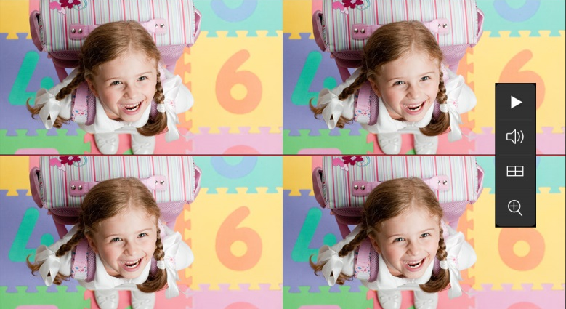
You can select to tap the icon in one of the division window and select one camera in the Select a Camera interface.
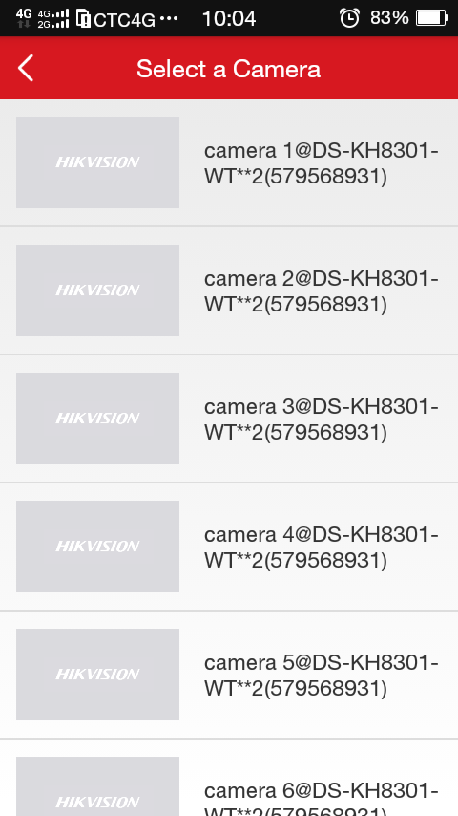
Or drag the target live view window in the 4-window division mode to the upper side of the interface to delete the window. The displayed icon will turn to .
Note: When you drag and move the selected window, will be displayed at the top of the interface. When you drag the selected window to the icon, the displayed will turn to .
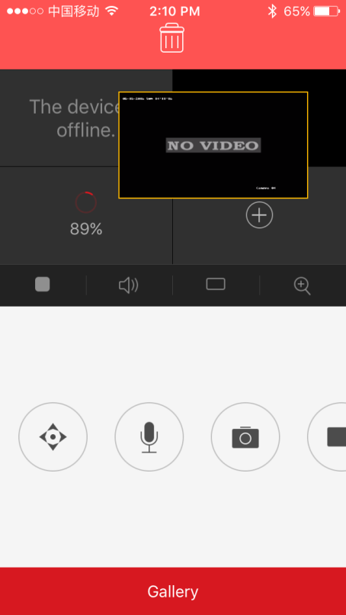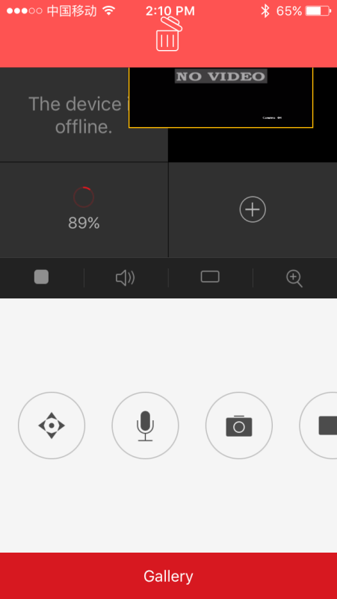
- Tap the target live view window.
- Tap the icon to start the live view.
Tap the icon to stop the live view.

Switching Window Division
Tap the icon to switch from the 4-window division mode to the single-window division mode.
Or tap the icon to switch from the single-window division mode to the 4-window division mode.
Or double-tap the target live view window in the 4-window division mode to enter the single-window division mode of the target live view window.

Turning On/Off Audio
Purpose:
You can control the audio of the selected camera.
Steps:
- Select the camera in the 4-window division mode.
Or double tap the target window to enter the single-window division mode.
- Tap the icon to turn on the audio of the target camera.
Or tap the icon to turn off the audio.

Performing Digital Zoom
Steps:
- Select a camera in the 4-window division mode.
Or double tap the target window to enter the single-window division mode.
- Tap the icon .
Or if you are in the single-window division mode, spread two fingers to digital zoom in.
- The selected area will be zoomed in.
Or if you are in the single-window division mode, you can also pinch two fingers together to digital zoom out.

Controlling Pan and Tilt
Steps:
- In the live view mode, select a live view window.
- Tap the icon to enter the control panel.
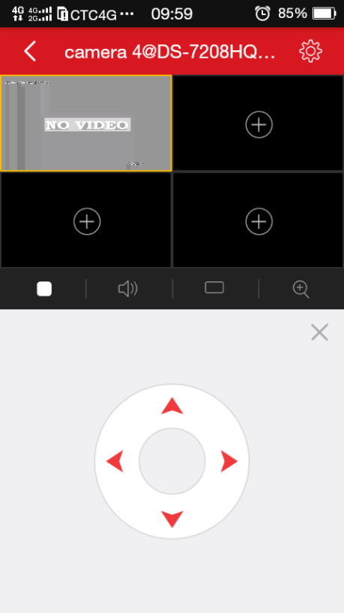
- Tap 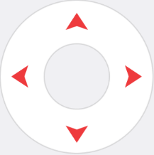 control the camera PTZ.
Note: The pan and tilt control function should be supported by the added device.

Turning On/Off Two-way Audio
Two-way audio function enables the voice talk of the devices. You can get not only the live video but also the real-time audio from the device.
Step:
- Select a camera in the 4-window division mode.
Or double tap the target window to enter the single-window division mode.
- Tap the icon 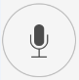 to turn on the two-way audio of the target camera.
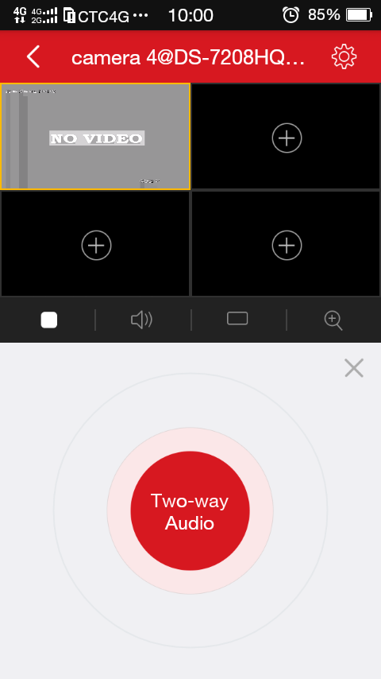
Or click the icon to turn off the two-way audio.
Note: If the device is full duplex, you are able to start two-way audio immediately after tapping the icon 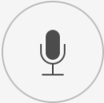. If the device is half-duplex, you have to tap and hold the button 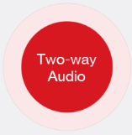 to start talking. If you want to listen, release the button.

Capturing and Recording
Steps:
- Select a camera in the 4-window division mode.
Or double tap the target window to enter the single-window division mode.
- Tap the icon 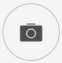 to capture the picture.
Or tap the icon to record the live view. And tap the to stop record.
Note: Captured pictures and recorded videos will be saved in Pictures and Videos in the More interface. For details about managing the pictures and videos, see Section 8.1 Managing Pictures and Videos.

Checking the Live View Quality
Two pre-defined image qualities are provided in this software: Basic and High Definition.
Steps:
- Tap the icon / to enter the quality switching panel.
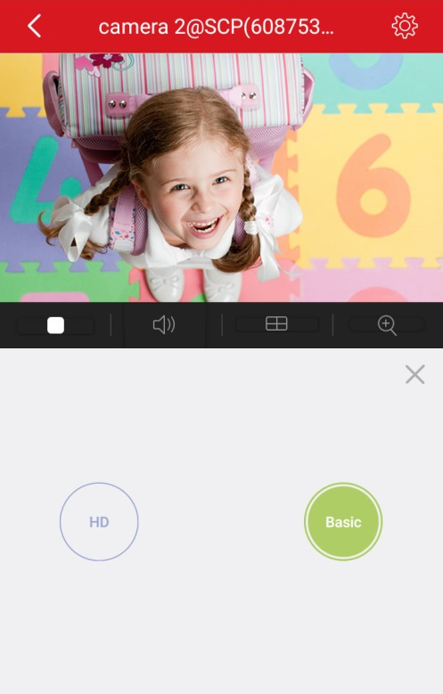
- Tap / to change the video quality.
Basic: Basic video quality.
HD: Video image with high definition.
Note: The Basic quality is the default video quality.

Opening the Door (Video Intercom Device)
Purpose:
For video intercom devices, you can open the door via the software.
Steps:
- Select a target live view window.
- Tap the icon to open the corresponding door.
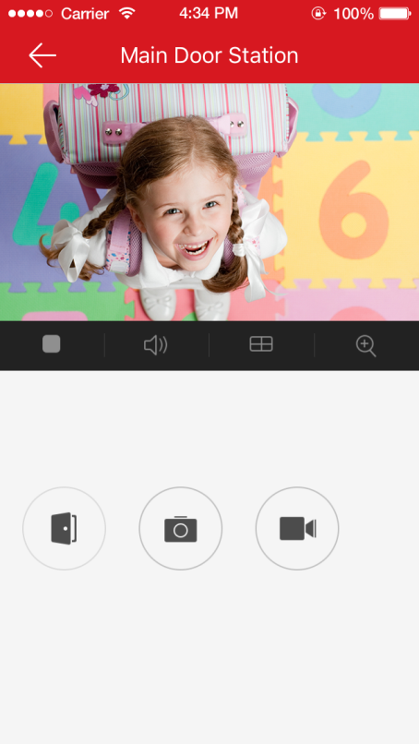
Notes:
- This function is only for the video intercom device.
- The live view duration for the video intercom device is 5 minutes.
- Up to 6 users can check the live view of the same door station at the same time. The other users can only use the audio function.

Remote Playback
Purpose:
You can check the recorded videos stored in the added device for playback.
Steps:

- Tap the home icon 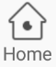 and tap the target device screenshot on the home interface to enter the Live View interface.
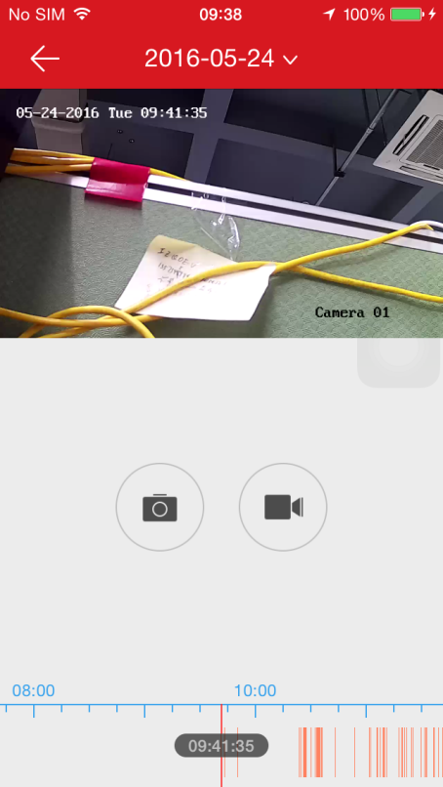
- Tap Gallery at the bottom of the live view interface.
The following table displays the icons in the Playback interface:
Icon | Descriptions
 | Start live view.
 | Stop live view.
 | Turn Audio On/Mute
 | Capture.
 | Record.

Starting and Stopping Playback
Steps:
- Tap the date on the upper side of the interface to enter the Calendar interface.
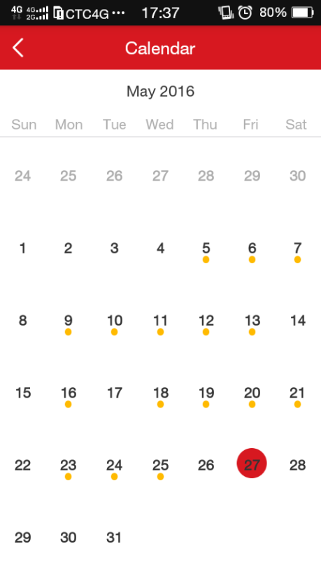
- Select a date with videos (the date with a yellow dot under) in the Calendar interface.
- Slide the timeline bar to adjust the playback time.
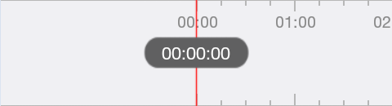
- Tap the icon to start playback.
Or tap the icon to stop playback.

Turning On/Off the Audio
Tap the icon to turn on the audio when the selected video is playing. Or tap the icon mute.

Capturing and Recording
During the playback, you can tap the icon to capture pictures or tap the icon to record the target video clip.
The captured pictures and the clipped videos can be checked and managed in the Pictures and Videos interface.
Note: For details about managing the pictures and videos, see Section 8.1 Managing Pictures and Videos.

Alarm Notifications Configuration
Purpose:
You can configure the alarm notifications in Alarm Notification interface. The device will push the alarm notification to your phone. You can also read and delete the alarm notifications in the Message interface.

Enabling/Disabling Alarm Notification
Steps:
- Tap the device name in the Home interface to enter the Settings interface if there is only one channel under the device.
Or if there is more than one channel under the selected device, tap the device name and tap the icon at the upper-right corner to enter the Settings interface.
For the security control panel, if there is more than one channel under the selected device, tap the device name and tap the linked device to enter the linked device Settings interface.
- Tap Alarm Notification to enter the Alarm Notification interface.
- Tap the icon / to enable/disable Alarm Notification.
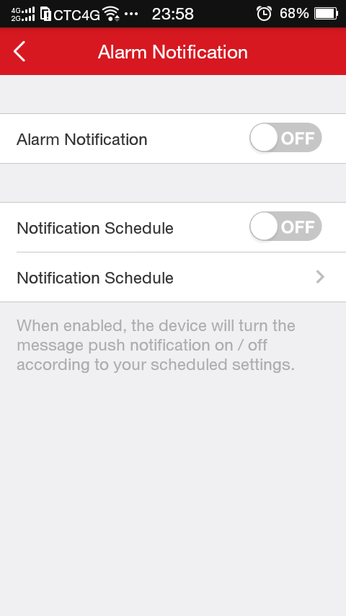
You can also
- Tap the icon on the right of Notification Schedule to enable the Notification Schedule.
- Tap Notification Schedule to enter the Notification Schedule interface.
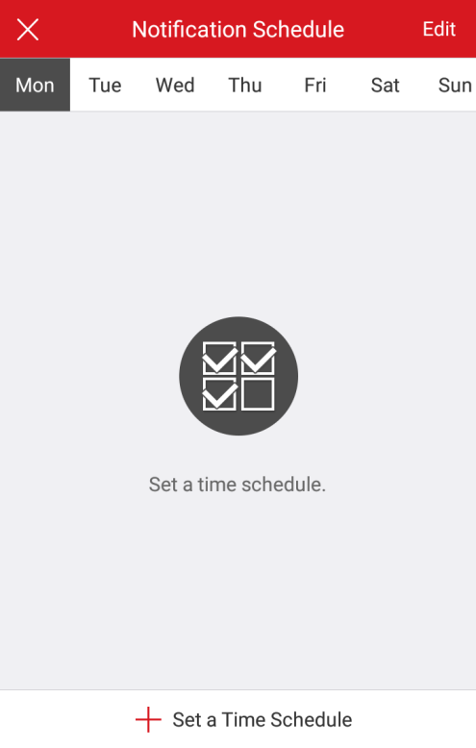
- Tap Set a Time Schedule.
- Tap Start Time, End Time, and slide to select the time.
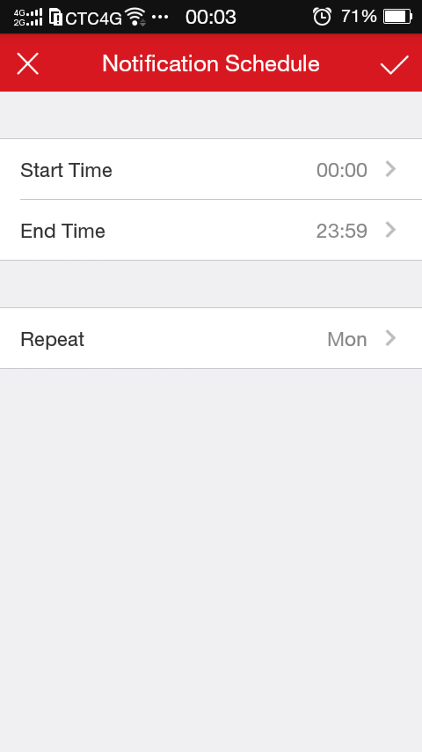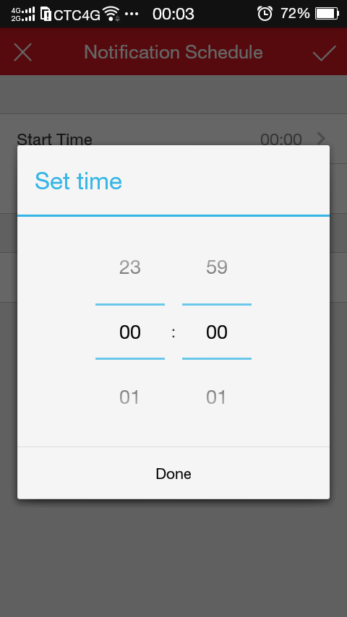
Optionally, tap Repeat and select the day you want to repeat.
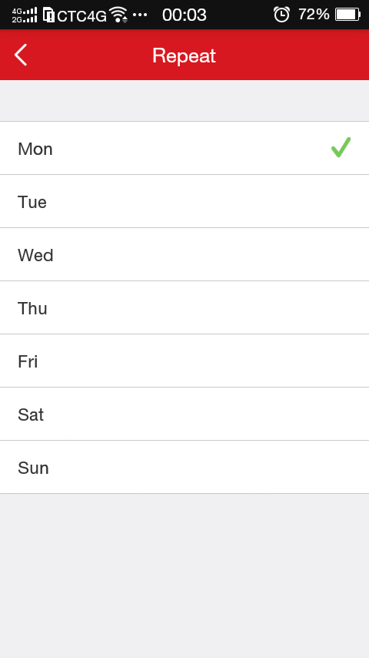
- Tap the icon to go back to the Notification Schedule interface and tap the icon to confirm the setting.
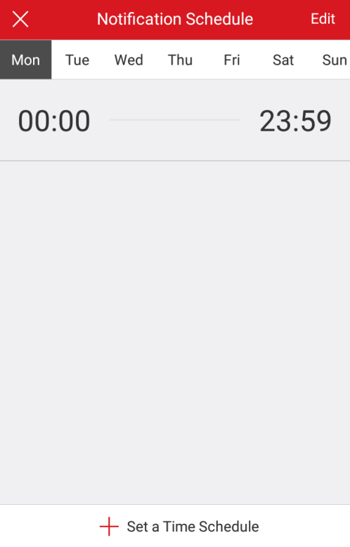
You can also tap Edit at the upper-right corner of the interface and select a schedule. Tap Delete to delete the schedule. Or tap Cancel to cancel the operation.
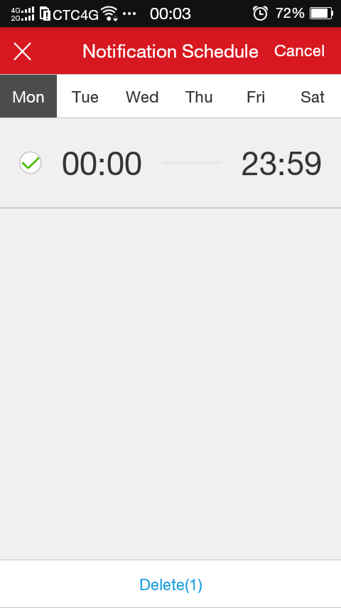
Or
- Tap the schedule in the Notification Schedule interface to edit the schedule.
- Tap Start Time or End Time to modify.
- Tap the icon to confirm editing.
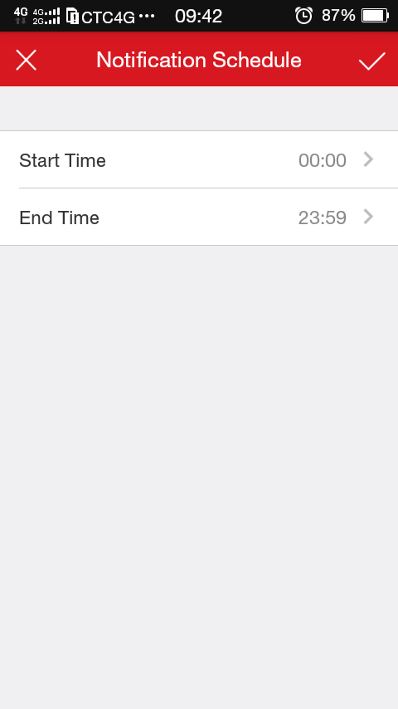
Notes:
- If enable Alarm Notification, the device will push the alarm messages according to configured notification schedule. For details about setting event (except for the video intercom device), see the device user manual.
- The security control panel does not support the Notification Schedule function.

Reading the Alarm Message
Steps:
- Tap the icon 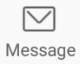 to enter the Message interface.
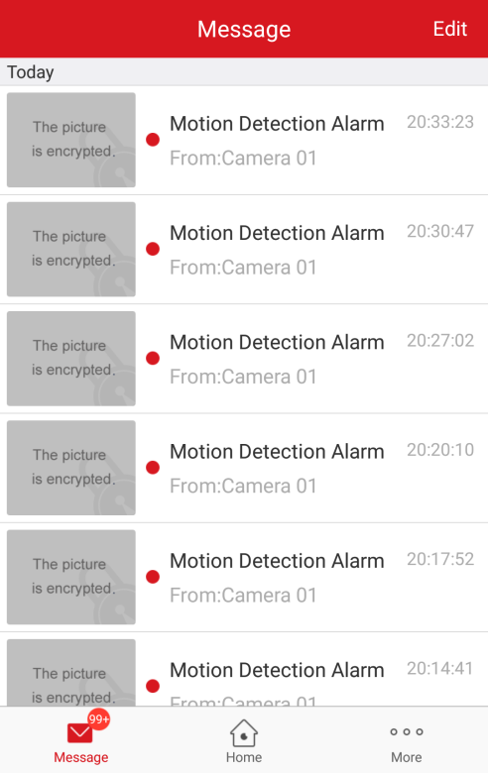
- Tap the unread messages to view the message.
Or
- Tap Edit at the upper-right corner of the interface.
- Tap Mark All as Read to mark all unread messages as read.
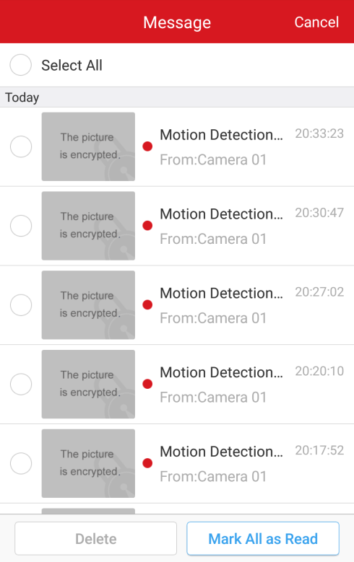
For the alarm messages of the security control panel, you are able to check the alarm started information:
- Click a security control panel alarm message and tap Playback to view the playback video when the alarm is started.
- Tap the icon at the upper right corner.
- Tap Live View to check the camera live view
Or tap Save to save the video to the mobile phone album.
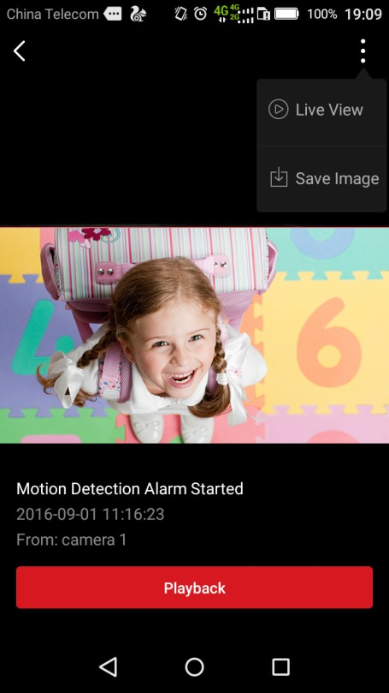
Notes:
- The message with a red point is the unread message.
- The calling messages of the video intercom device cannot be displayed in the Messages interface.

Deleting the Alarm Message
Steps:
- Tap the icon to enter the Message interface.
- Tap Edit at the upper-right corner of the interface.
- Select multiple messages or tap Select All.
- Tap Delete to delete the selected messages.
Or tap Cancel to cancel the operation.
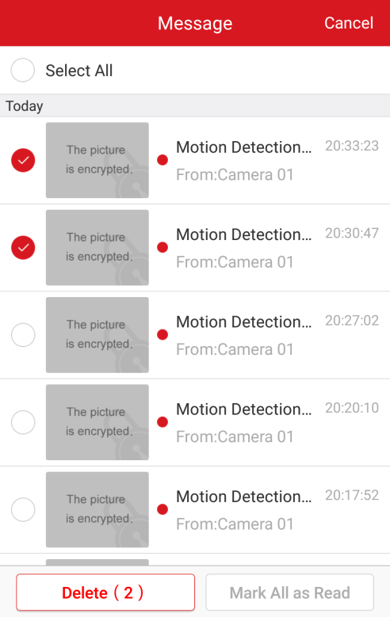

Alarm Messages of Video Intercom Device

Checking the Calling Message
Purpose:
If no one answers the call of the indoor station for a while, the call will be forwarded to the software.
Note: The call forwarding time duration can be set on the indoor station setting interface. The available time duration that can be set is from 0 to 20s.

Steps:
- Tap the calling message. A calling interface will be popped up.
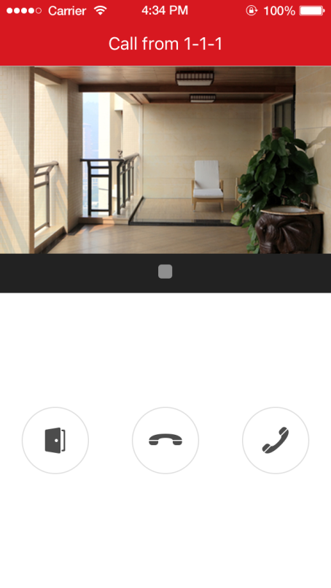
- Tap the icon 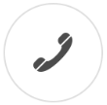to enter the live view interface of the video intercom device.
Or tap the icon 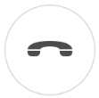 to decline the call.
- In the door station interface, tap the icon or to play or stop the door station live view.
Or tap the icon 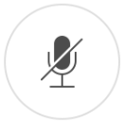 to mute.
Or tap the icon to hang up.
Or tap the icon 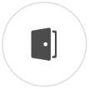 to open the door.
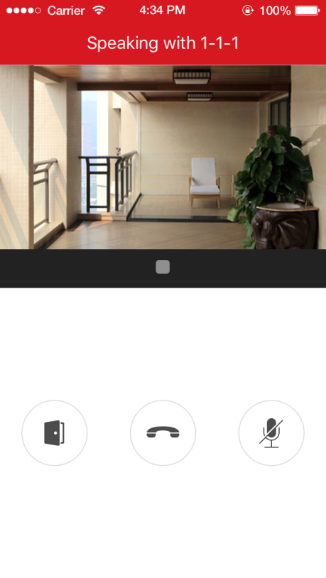
Notes:
- If you do not answer the call, the calling interface will be keep until the call is hanged up. A message will pop up on your phone.
- Up to 6 users can check the live view of the same door station at the same time. For more than 6 users, other users cannot use the live view function. Only the audio function can be used.

Receiving Alarm Messages
Purpose:
When the device sensor is triggered, the alarm information will be sent to your phone.
For details about event configuration, see the user manual of the video intercom device.
Before you start:
- The indoor station has linked to the sensor and it has been armed.
- The sensor is triggered.

Tap the triggered alarm message on your mobile phone to enter the Message interface to check. For details about operating in Message interface, see Section 7.2 Reading the Alarm Message and Section 7.3 Deleting the Alarm Message.
Or if you do not operate, the message will be hidden.

More Configuration
Purpose:
In the More interface, you can manage pictures, videos and accounts, save device parameters, send feedbacks, and view the software version, terms of services and the privacy statement.

Managing Pictures and Videos

Managing the Video
Steps:
- Tap the icon 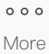 to enter the More interface and tap Pictures and Video.
- Tap the target video file to enter the interface for video playing.
Note: The files with are video files.
- Tap the icon or the icon to play the video.
Or tap the icon to pause.
Or tap the icon to delete the video.
Or tap the icon to go back to the previous interface.
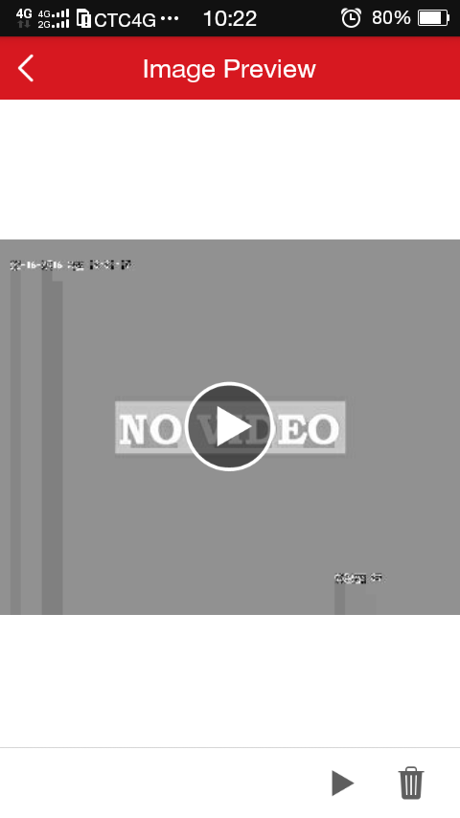

Managing the Picture
You can save or delete the selected picture.
Steps:
- Tap the icon to enter the More interface and tap Pictures and Videos.
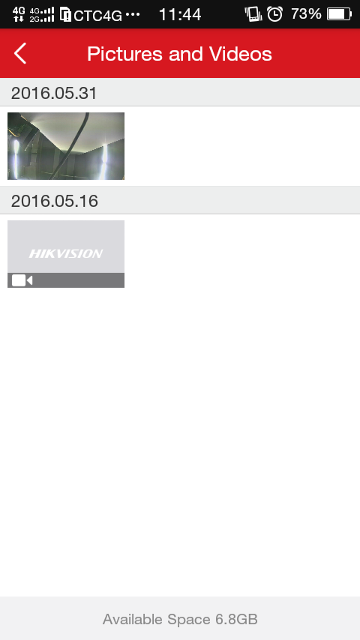
- Tap the target picture to enter the interface for picture managing.
Note: The files without are picture files.
- Tap the icon to delete the picture.
Or tap the icon to go back the previous interface.

Managing the Account
Tap the icon to enter the More interface and tap Account Management to enter the Account Management interface.
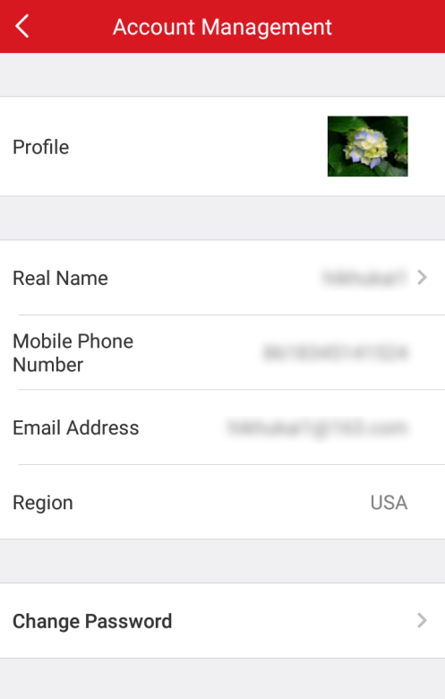

Changing Profile
Steps:
- Tap Profile to change the profile picture.
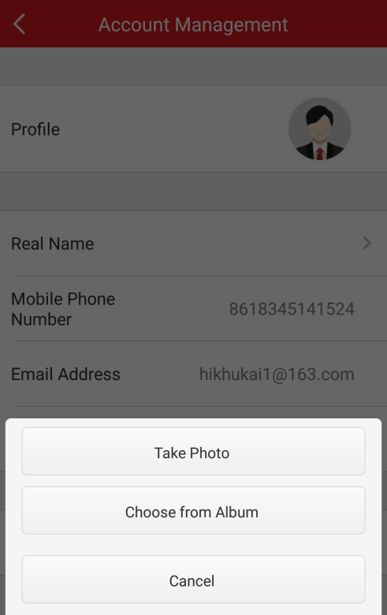
- Tap Take Photo to take a new photo as the profile picture.
Or tap Choose from Album to select a picture from your album.
Or tap Cancel to cancel the operation.

Editing Real Name
Purpose:
You can edit the real name of the account.
Steps:
- Tap Real Name to enter the Edit Real Name interface.
- Input your real name in the box.
Note: 2-50 characters are allowed.
- Tap to confirm editing.

Changing Account Password
Steps:
- Tap Change Password to enter the Change Password interface.
- Input the old password, the new password and confirm the new password in the box.
- Tap to confirm password changing.
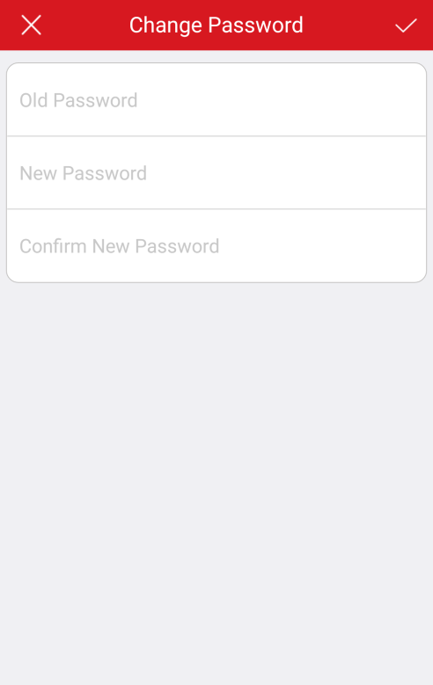

Checking Other Information
In the Account Management interface, you can also check the account linked mobile phone number, the account email address and the region.

Function Settings

Enabling/Disabling Message Push Notification
Tap / to disable/enable Message Push Notification. When enabling the function, the triggered alarm massages will be saved in Message interface. For details, see Chapter 7 Alarm Notifications Configuration.
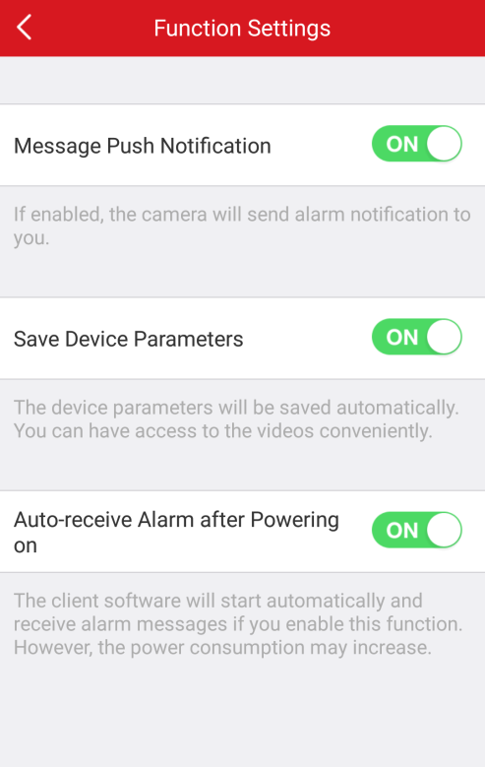

Saving Device Parameters
Purpose:
You can enable Save Device Parameters to save the device parameters such as the image encryption password. If you enable the function, you will be no need to input the password every time you enter the live view interface.
Tap the icon to enable Save Device Parameters.
Or tap the icon to disable the function.

Enabling/Disabling Auto-receive Alarm after Power-on
Tap / to disable/enable Auto-receive Alarm after Power-on.
Notes:
- The software will start automatically and receive alarm messages if you enable this function.
- The power consumption may increase.

Sending Feedbacks
If there is any problem or suggestion when you use the software, feel free to send feedbacks to us.
Steps:
    - Tap Feedback in the More interface.
    - Input your questions or advices.
    - Tap to send the feedback. Our technical engineers will handle your problems and suggestions as soon as possible.
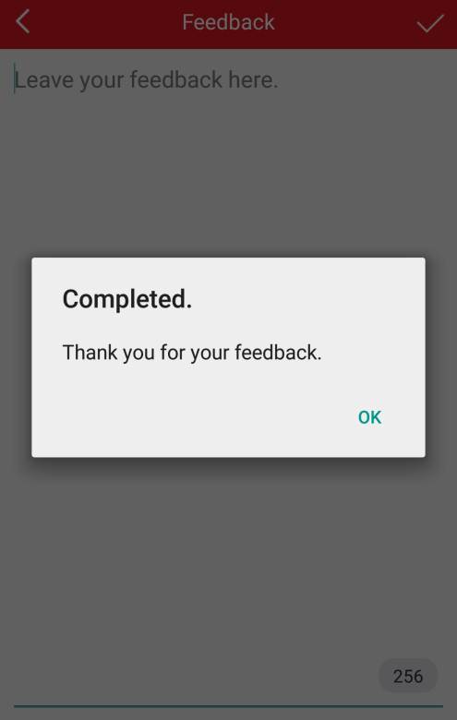

Checking About
In the More interface, tap About to check updates, terms of service and privacy statement.
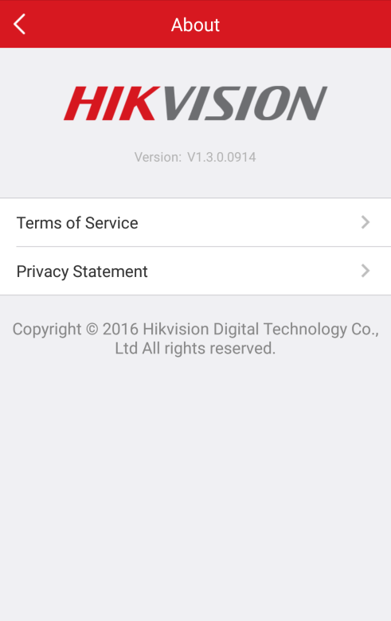

0102001060918
