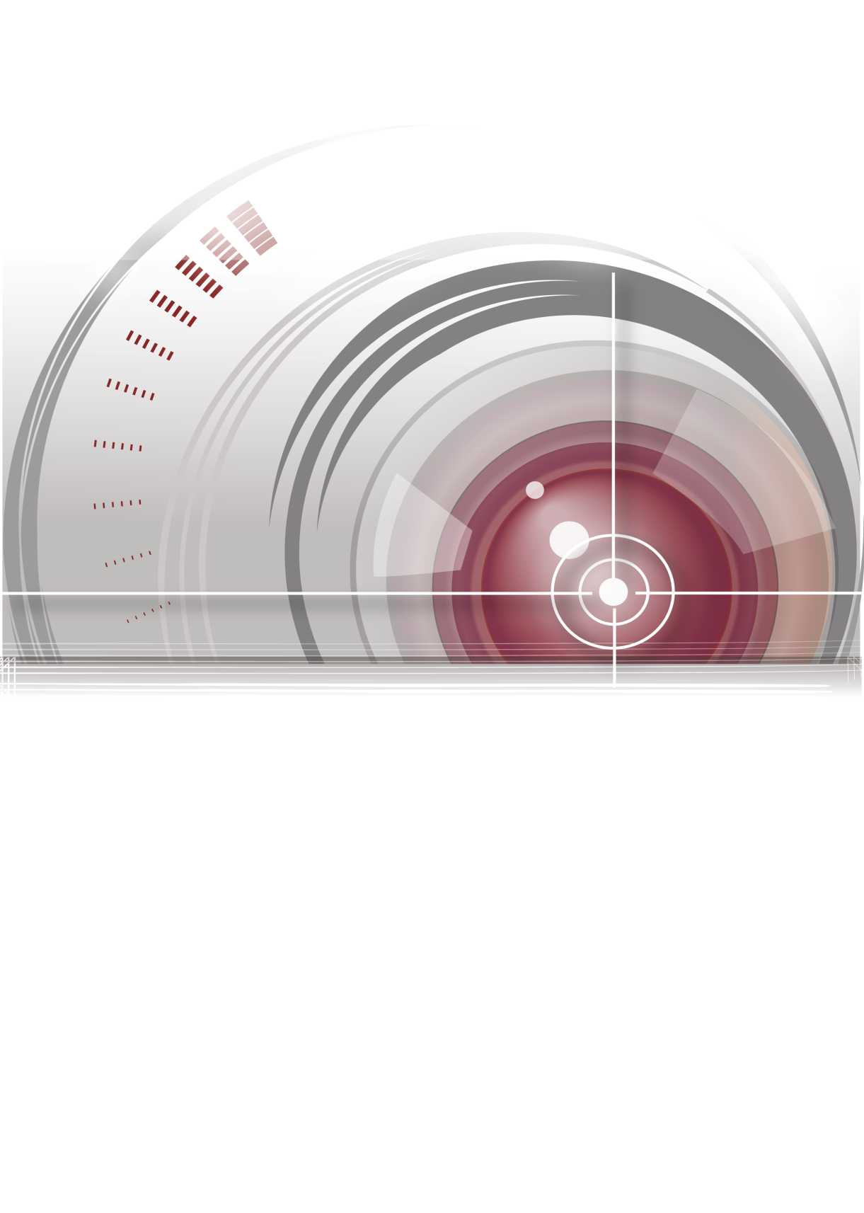

Secure Door Control Unit

User Manual
V1.0.0
UD01463N

About this Manual
This Manual is applicable to Secure Door Control Unit.
The Manual includes instructions for using and managing the product. Pictures, charts, images and all other information hereinafter are for description and explanation only. The information contained in the Manual is subject to change, without notice, due to firmware updates or other reasons. Please find the latest version in the company website.
Please use this user manual under the guidance of professionals.
Legal Disclaimer
REGARDING TO THE PRODUCT WITH INTERNET ACCESS, THE USE OF PRODUCT SHALL BE WHOLLY AT YOUR OWN RISKS. OUR COMPANY SHALL NOT TAKE ANY RESPONSIBILITIES FOR ABNORMAL OPERATION, PRIVACY LEAKAGE OR OTHER DAMAGES RESULTING FROM CYBER ATTACK, HACKER ATTACK, VIRUS INSPECTION, OR OTHER INTERNET SECURITY RISKS; HOWEVER, OUR COMPANY WILL PROVIDE TIMELY TECHNICAL SUPPORT IF REQUIRED.
SURVEILLANCE LAWS VARY BY JURISDICTION. PLEASE CHECK ALL RELEVANT LAWS IN YOUR JURISDICTION BEFORE USING THIS PRODUCT IN ORDER TO ENSURE THAT YOUR USE CONFORMS THE APPLICABLE LAW. OUR COMPANY SHALL NOT BE LIABLE IN THE EVENT THAT THIS PRODUCT IS USED WITH ILLEGITIMATE PURPOSES.
IN THE EVENT OF ANY CONFLICTS BETWEEN THIS MANUAL AND THE APPLICABLE LAW, THE LATER PREVAILS.
Regulatory Information
FCC Information
FCC compliance: This equipment has been tested and found to comply with the limits for a digital device, pursuant to part 15 of the FCC Rules. These limits are designed to provide reasonable protection against harmful interference when the equipment is operated in a commercial environment. This equipment generates, uses, and can radiate radio frequency energy and, if not installed and used in accordance with the instruction manual, may cause harmful interference to radio communications. Operation of this equipment in a residential area is likely to cause harmful interference in which case the user will be required to correct the interference at his own expense.
FCC Conditions
This device complies with part 15 of the FCC Rules. Operation is subject to the following two conditions:
1. This device may not cause harmful interference.
2. This device must accept any interference received, including interference that may cause undesired operation.
EU Conformity Statement
This product and - if applicable - the supplied accessories too are marked with "CE" and comply therefore with the applicable harmonized European standards listed under the EMC Directive 2004/108/EC, the RoHS Directive 2011/65/EU.

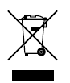
2012/19/EU (WEEE directive): Products marked with this symbol cannot be disposed of as unsorted municipal waste in the European Union. For proper recycling, return this product to your local supplier upon the purchase of equivalent new equipment, or dispose of it at designated collection points. For more information, see: www.recyclethis.info.

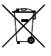
2006/66/EC (battery directive): This product contains a battery that cannot be disposed of as unsorted municipal waste in the European Union. See the product documentation for specific battery information. The battery is marked with this symbol, which may include lettering to indicate cadmium (Cd), lead (Pb), or mercury (Hg). For proper recycling, return the battery to your supplier or to a designated collection point. For more information see: www.recyclethis.info.
Industry Canada ICES-003 Compliance
This device meets the CAN ICES-3 (A)/NMB-3(A) standards requirements.
Preventive and Cautionary Tips
Before connecting and operating your device, please be advised of the following tips:
- Ensure unit is installed in a well-ventilated, dust-free environment.
- Keep all liquids away from the device.
- Ensure environmental conditions meet factory specifications.
- Ensure unit is properly secured to a rack or shelf. Major shocks or jolts to the unit as a result of dropping it may cause damage to the sensitive electronics within the unit.
- Use the device in conjunction with an UPS if possible.
- Power down the unit before connecting and disconnecting accessories and peripherals.
- A factory recommended HDD should be used for this device.
- Improper use or replacement of the battery may result in hazard of explosion. Replace with the same or equivalent type only. Dispose of used batteries according to the instructions provided by the manufacturer.
Preventive and Cautionary Tips
To guarantee the card reader works properly, please read and obey the Notices below.
- If the card reader is powered by the controller, the power supply distance is recommended to be no longer than 100m. If the distance is longer than 100m, you are advised to power the card reader by external 12V (range: -%10 ~ +%10) DC power supply, which is nonswitched and linear.
- To guarantee the communication between the controller and the card reader, you must use RVVP cable above 0.5 to connect them.
- If the card reader is installed outside or in environment easy to permeable, it is advisable to install a waterproof shield.
- If you need to install several card readers, the distance among them must over 30cm.
- To reduce the noise in long distance transmission, the shield of cable should connect to the GND of both controller and card reader terminal.
Contents
Chapter 1 Overview 2
1.1 Introduction 2
1.2 Introducing the Appearance 2
1.2.1 Front View 2
1.2.2 Rear View (Dial-up) 2
1.3 Introducing Indicators 3
Chapter 2 Installation 5
2.1 Introduction of DIP Switch 5
2.2 Wiring Cables 6
2.3 Installing Secure Door Control Unit 9
Chapter 3 Wiring External Device 10

Overview

Introduction
DS-K2M060 Secure Door Control Unit (hereinafter referred as “unit”) can be applied to keep the door in the status before down when the door is down or damaged.
DS-K2M060 Secure Door Control Unit is the interlayer between the access control terminal and the lock, including the door contact, the lock, the exit button, the Wiegand card reader and so on. It is much more safer to apply the secure door control unit with the access control terminal.

Introducing the Appearance

Front View
The front view Secure Door Control Unit is shown as below:
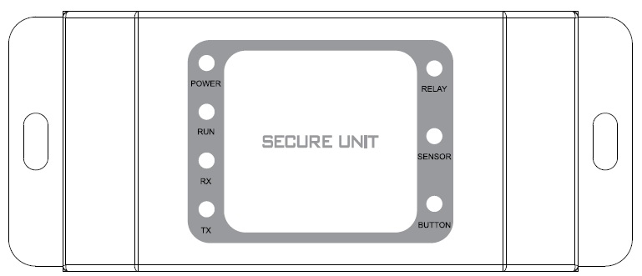
          - Front View of Secure Door Control Unit

Rear View (Dial-up)
The rear view of Secure Door Control Unit is shown as below:
          - Rear View of Secure Door Control Unit
            - Description of Rear View
No. | Name
1 | Cable Interface of RS-485, Power, LED Control, etc.
2 | Tampering Prevention Switch
3 | DIP Switch (For details, see Chapter 2.1 Introduction of DIP Switch)
4 | Wiegand Interface

Introducing Indicators
The indicators of Secure Door Control Unit are POWER, RUN, RX, TX, RELAY, SENSOR and BUTTON.
The following tables introduce the meaning of different indicator’s status:
POWER:
Solid Red | The unit is powered on.
RUN:
Flicking Green | The tempering prevention switch is open. Tempering alarm.
Solid Green | The tempering prevention switch is open. The device is running.
RX, TX - RS 485 Communication Indicator:
Flicking Green | The RS 485 communication is built.
Solid Greed | The RS 485 communication is not built.
RELAY: Indicate the lock status:
Green | The indicator will be solid green for a while when the opening door action is done. (The opening door action includes swiping the card, remote opening door and so on.)  Notes:  - Make sure the unit is powered on.  - Make sure the unit is connecting the lock.
SENSOR – Indicate the door magnetic status:
Green | The indicator is solid green when the door is open. When the door is closed, the indicator is off.  Notes:  - Make sure the unit is powered on.  - Make sure the unit is connecting the door magnetic.
BUTTON – Indicate the Exit button
Green | The green light is on when press the Exit button. When release the button, the green light will be off.  Notes:  - Make sure the unit is powered on.  - Make sure the unit is connecting the Exit button.

Installation

Introduction of DIP Switch
For the DIP switch position, please refer to No.3 of Table 2.1 Description of Rear View. The DIP switch module is shown below. The number of DIP switch from left to right is 1 to 4.
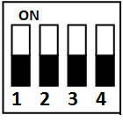
          - DIP Switch Module (Binary Code: 0000)

The table shows below is the description of the DIP switch.
            - Description of DIP Switch
Icon | Description
 | Represent 1 in binary mode
 | Represent 0 in binary mode

For example, the binary codes of the following figure from No.1 to 4 are 0011 respectively.
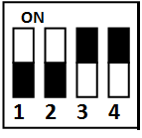
          - DIP Switch Module (Binary Code: 0011)

The DIP switch in the secure door control unit is for the RS-485 communication. The code range is from 1 to 15, namely the binary code range between 0001 and 1111. The code cannot be repeated.

Wiring Cables
Purpose:
Wire cables between Access Control Terminal, Secure Door Control Unit and the lock input/output devices (Wiring to the Wiegand card reader is optional.) to establish the communication between them.

Steps:
- Set the DIP switch code. The binary code range is between 0001 and 1111. For details, please refer to Chapter 2.1 Introduction of DIP Switch.
- Plug the Terminal 1 to the Interface 1 as shown in Figure 2.3 and Figure 2.4.
          - Terminals 1
The table displayed below shows the terminal 1 description:
            - Terminals Descriptions of Secure Door Control Unit
Group | Cable No. | Color | Name | Descriptions
A | A1 | Red | +12V | Power Input
 | A2 | Black | GND
B | B1 | Green/Brown | DOOR_SENSOR | Sensor Input
 | B2 | Black | GND
C | C1 | Green/Black | DOOR_BUTTON | Door Button
 | C2 | Black | GND
D | D1 | White/Purple | RELAY_NC | Lock Output
 | D2 | White/Black | RELAY_COM
 | D3 | White/Red | RELAY_NO
E | E1 | Yellow | RS485 + | RS-485
 | E2 | Black | GND
 | E3 | Blue | RS485 -
          - Rear View of Secure Door Control Unit
- Plug the Wiegand Terminal 2 to the Wiegand interface as shown in Figure 2.5 and Figure 2.6. The Interface 2 represents the Wiegand interface.
          - Terminals 2
The table displayed below shows the terminal 2 descriptions:
            - Terminals Descriptions of Secure Door Control Unit
Group | Cable No. | Color | Name | Descriptions
F | F1 | Brown | OK | Wiegand
 | F2 | Purple | BUZZER
 | F3 | Orange | ERR
 | F4 | Green | W0
 | F5 | White | W1
 | F6 | Black | GND
          - Rear View of Secure Door Control Unit

Installing Secure Door Control Unit
Steps:
- Drill holes on the wall or other places according to the mounting template.
Note: The minimum bearing weight of the wall or other places should be three times heavier than the device weight.
- Insert the screw sockets of the setscrews in the drilled holes.
- Plug the cables of power input, lock input, lock output and RS-485 as well as the Wiegand cables to the target interfaces. (For details, please see Chapter 2.2 Wiring Cables)
- Align the screw holes on the two sides of the secure door control unit with the holes on the wall.
- Fix and fasten the secure door control unit on the wall by the supplied screws.
Note: Knock down the hole on the one side of the unit, as shown in Figure 3.5, if cables need to go from the side.
          - Fix on the Wall

Wiring External Device
The figure displayed below is the wiring introduction of external device:
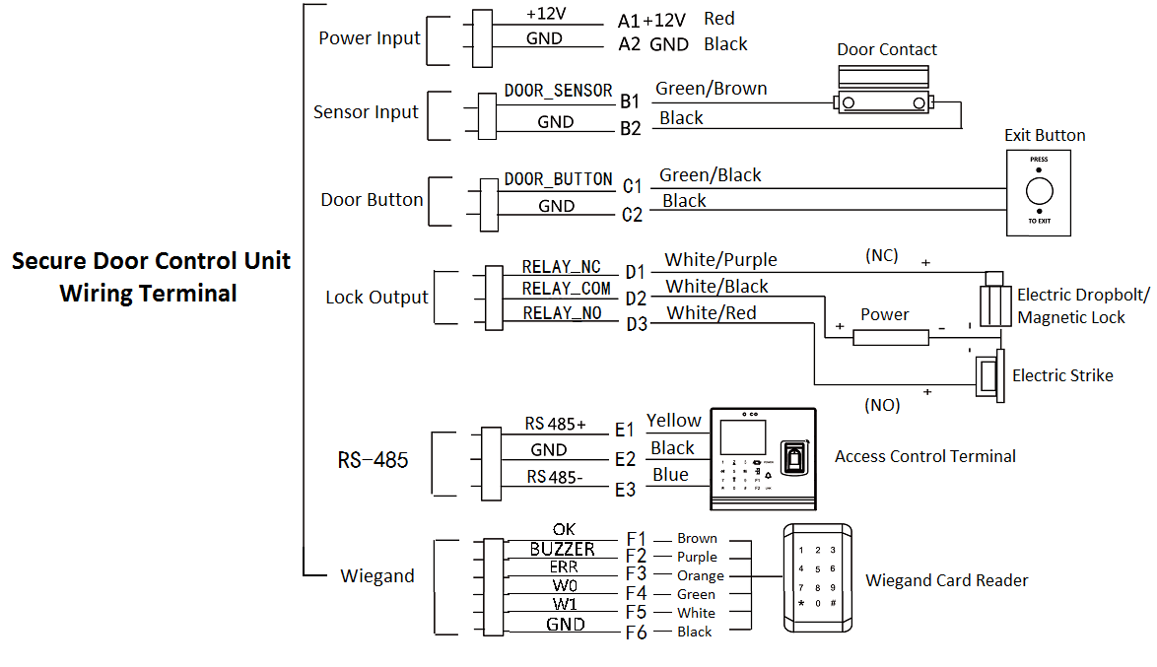
          - External Device Wiring

0100001060602

